Running on Empty: The Effect of Airbnb Markets  
 Surrounding Major Marathon Races in 2024

Drew Duffy Josh Garzaniti Max Hurleman Nolan Santacroce

Spring 2025

**Contents**

1. Executive Summary……………………………………… ……………………………………………… 2
2. Data Description ………………………………………………………………………………………….. 3
3. Exploratory Data Analysis …………………………………………………………………………….. 4
4. Primary Analysis ……………………………………………………………………………………………6
5. Conclusion and Future Goals .…………………………………………………………………………15
6. Sources…………….……………………………………………………………………………………………16
7. Appendix ………………………………………………………………………………………………………17

Goal of the Study

The purpose of this project is to explore different trends in short-term housing rentals around anticipated heavy tourism weekends. Instead of using tourism as a general term, we focused on days surrounding some of the United State's most popular running events. Marathon running has been an increasingly popular activity for many around the world, and the United States boasts some of the best race environments. As of 2024, the New York Marathon broke the world record for the most finished with 55,646. (Lewellyn) High participation statistics, and increased attendance records, coupled with the prestige of some of the American races make for an interesting effect to study the impact on short-term housing rentals in major U.S cities around some of these prestigious events.

The sport of marathon racing was our main focal point for two main reasons. First, it targets a similar interest group regardless of where races are being held. This has allowed us to make similar comparisons between different races and how they are structured in terms of routes and timing over the course of a year. Secondly, we believed that marathon racing was a more consistent “tourism” event, compared to athletic competitions, art performances, or music festivals. A lot of these events that draw tourists to a certain destination are much more performance based. By this, we mean that there are more external factors that will force someone to attend, such as the success of a specific team or group, the talent level of individuals (think a Broadway show), or the profile of a performer or groups of performers (concerts and music festivals). We believe that marathon racing is a unique target to look into due to its relatively consistent nature and common denominator across all locations: a 26.2 mile route (42.16 km).

The goal in terms of analysis scope was to see if we could both visualize short term rentals in the local market around these marathon events in terms of pricing, availability before and during major race events and visualize the structure of Airbnbs as they pertain to around course layout, and lastly determine if there were specific factors that impacted availability, and the booking of specific units around these weekends.

Data Description

By using publically available Airbnb data, we are able to keep a consistent source across different locations and time frames. We used our data from InsideAirbnb.com, a website that aggregates data from some of the most popular Airbnb destinations around the world.

We focused our project around five main marathon races. Our choices of Boston, Chicago, Denver, New York, and San Francisco were intentional, as we hoped to capture some of the most popular races around the United States along with a widespread geographic showing for all timezones in the United States. New York, Boston, and Chicago are three of the biggest races worldwide, but including San Francisco and Denver gave us more data points based on different factors apart from the prestige of a race.

Each of these cities was aligned with a dataframe of corresponding AirBnB data for 2024. Each data frame contains over 1,500,000 observations, so there is more than enough substance in terms of volume over the 2024 year to analyze in terms of listings. Within each of these unique city data frames exists 78 columns(this was later narrowed down to primarily 40 variables). Some of the highlights of these AirBnB variables include: *listing ID*, *date*, *price* (in dollars), *availability*, *maximum* and *minimum nights*, the *name* and *location* of each listing, each listing’s number of *rooms*, *bedrooms*, *total accommodations*, *amenities* etc alongside host specific data pertaining to their *name*, host-specific statuses (binary categoricals), and *review ratings* (continuous numericals or ordered factors). Availability columns were also present in the data representing the listing’s availability over: 30, 60, 90, and 365 days of the year. The emphasis on this study was to primarily focus on pricing structure, availability, and location as it pertains to each listing and their respective distance both within city-proper limits and from the course layout for each marathon (as will later be analyzed).

The cleaning and data transformation process was a bit extensive as variables had to be mutated into correct data types while also new derived variables and binary factor columns were created out of existing data. First, any host “True or False” binary categorical variable such as: *has_identity_verified*, *is_superhost*, *has_profile_pic* etc were mutated into binary numeric columns. Then columns composed entirely of NA values such as: *neighbourhood_group_cleansed*, *adjusted_price* and *calendar_updated* were also dropped from the data sets because they added no value to future analysis. When loading in the New York data, at first only data from September of 2024 through December of 2024 appeared. When correcting this to obtain a wider historical range (as was done originally with other data frames), it was realized that to load in a historical year’s worth of observations, only 24 variables could be taken, purely because a year’s worth of New York Airbnb data consists of over 13 million rows, and as such the *RDS* file wouldn’t load locally into *Rstudio* without making adjustments to the amount of features. It was still made sure that New York data consisted of all important variables (availability, pricing, location via coordinates etc).

Exploratory Data Analysis

An initial note on pricing….While pricing was expected to be utilized more during this analysis, initial exploration during EDA resulted in static graphs for time-series related queries. Airbnb pricing structures appeared to not change as dynamically (Figures 17- 21) as availability for the major weekends that were an emphasis of analysis during this study, so a heavier focus was placed on availability versus dynamic pricing impacts.

Exploratory Data Analysis on the five key dataframes produced initial visualizations that upon further examination displayed relationships between listing availability or rather the lack thereof and major racing events of emphasis. Data was first grouped by unique *listing ID* and *neighborhood* to first capture the total amounts of individual listings within each neighborhood for each respective city.

Within Boston it was found that neighborhoods containing the most amount of listings included: Roxbury with 302, South End with 324, Back Bay with 370, Downtown with 372, and Dorchester with a city high 528 Airbnb units.

Denver by comparison was not as heavy of an Airbnb market as Boston. Top neighborhoods by listings included: 177 units in Berkeley, 201 around Union Station, 220 in West Colfax, 306 in Highland, and Five Points with 416.

San Francisco only had 37 neighborhoods but the amount of listings within their top 5 were significantly higher than other cities (outside of New York). These contained: Nob Hill with 401 listings, Western Addition with 502, South of Market at 558, Mission at 635, and lastly the Downtown/Civic Center holding approximately 1208 unique listings.

New York by comparison to all other cities both had the most number of neighborhoods and the highest number of Airbnbs (which was to be expected for such a large city). Their top 5 were composed of: Bushwick with 1536 rentals, Harlem with 1763, Midtown with 2053, Williamsburg with 2164, and Bedford-Stuyvesant with an incredible 2710 Airbnbs.

Lastly was the Chicago dataframe. Chicago, also a large hub, had fewer neighborhoods than Denver with 75, but their top 5 by listings were drastically higher. These included: the Loop with 541, Lake View with 594, Near West Side with 644, West Town with 792, and Near North Side containing 1028 listings.

After just looking at the breakdown of regional markets in terms of subsample sizes, those neighborhoods were then mapped via longitude and latitude mapping systems to create short term housing dentistry maps for each unique city. When first mapping the density of these housing markets, it became apparent that some of the data wasn’t transferring to mapview models correctly. Looking at San Francisco and New York’s visualizations (Figures 1 and 2 respectively), it’s unclear why some neighborhoods are being picked up correctly with the density of Airbnb listings (the color shaded areas), while others still within the city proper limits and known to have values within the dataset, were left grayed out as if listings didn’t exist in these areas, when they in fact did. Note that this was not an issue observed for the Chicago, Boston, and Denver mapview graphics (Figures 3, 4, and 5).

A simple observation of these maps yields the following:

* San Francisco’s highest density of Airbnbs lies within the Union Square general area.
* Chicago’s Airbnbs are heavily cluster up along the Near North Side
* New York’s market (via the graph) is clustered towards Williamsburg
* Boston’s market centers around the southern Dorchester area
* Denver’s market is heavily favored in the Ballpark district near Union Station

Next, each data frame was grouped by *date* and *listing ID* and the number of listings available was calculated through taking the sum of that binary numeric *available* variable where values were greater than 0 (to reflect that listing’s were indeed open). Groups were dropped and that was again grouped by date to calculate the average number of available listings (by taking the mean of the derived number of listings previously calculated). This allowed us to create a time series graph for each city where the average number of available listings was portrayed over the course of 2024.

Within the Boston average listings available time series (Figure 6). We noticed that the weekend of the Boston Marathon (April 15th, 2024) coincides directly with what appeared to be the largest drop in available listings that entire year for the city. Chicago’s time-series (Figure 7) displayed similar results. While the Chicago Marathon on Oct. 13th 2024 didn’t result in the largest drop of availability, it was a very significant decrease over the course of the year. Denver had more fluctuations of availability throughout 2024 than either Boston or Chicago as referenced by its graph (Figure 8). Again like Chicago, while the Colfax Marathon (May 18th, 2024) wasn’t in line with the largest decrease, it was a very noticeable one. San Francisco’s marathon on July 28th 2024 had by and large the weakest negative impacts of the cities studied as evidenced by its chart (Figure 9). With that said, it was a relatively noticeable drop in short term housing availability. Finally, when looking at New York City’s listings over time (Figure 10), it was noticed that while there is a drop in availability the week of the NYC Marathon, the dip is relatively minimal in comparison to both the year as a whole and the other major cities respectively.

Analysis

First pricing was model by neighborhood using each city’s respective neighborhood shapefile joined with the Airbnb respective data on “neighborhood”. Then,

Each city was visualized with choropleth graphs to display pricing by neighborhood. The visual results (Figures 22-26) speak for themselves in terms of where pricing values are clustered for each hub, but some highlights include:

* Boston Pricing Worst Neighborhoods - Downtown & Back Bay at 394.93 and 382.42 per night
* Boston Pricing Best Neighborhoods - Allston & West Roxbury at 125.76 and 129.38 per night
* Chicago Pricing Worst Neighborhoods- Clearing & the Loop at 1846.75 and 1477.54 per night
* Chicago Pricing Best Neighborhoods-West Englewood & East Side at 65.58 and 65.92 per night
* Denver Pricing Worst Neighborhoods- Elyria Swansea & Regis at 662.82 and 527.13 per night
* Denver Pricing Best Neighborhoods-Harvey Park South & Mar Lee at 78.67 and 85.30 per night
* New York Pricing Worst Neighborhoods-Theater District & Flatiron District at 2119.25 and 1694.17 per night
* New York Pricing BestNeighborhoods-New Dorp & Grant City at 57 and 62.84 per night
* San Francisco Pricing Worst Neighborhoods-Nob Hill & Financial District at 1515.90 and 1318.93 per night
* San Francisco Pricing Best Neighborhoods-Crocker Amazon & Golden Gate Park at 108.49 and 116.67 per night

After that, each city’s dataframe was grouped by unique listing ID and several derived metrics were calculated such as average number of available listings for each date, and average number of nights available for each listing. By using the inherent longitude and latitude of each unique listing, listings were then plotted out over maps to display neighborhoods color-coded by said derived metrics. For Boston, it can be observed that during the week of the *Boston Marathon* in 2024, The neighborhoods with the least amount of available nights per listing were Brookline, Cambridge, and Somerville. For New York they were Fort Wadsworth, Morningside Heights, and East and West Village. Likewise, the worst Airbnb listings by available nights in San Francisco around their annual marathon were Golden Gate Park, Russian Hill, and Pacific Heights. Denver as a whole ranged from 2.5 nights to 5 nights within the city proper limits during the *2024 Colfax Marathon* weekend, and it was only until one got out to *Pena Blvd.* near DIA and Four Square Mile just north of the *Tech Center* that there was more flexibility in terms of short rental stay duration. Chicago had neighborhoods like Gage Park, Garfield Ridge, and North Lawndale where the availability (in nights) fell to below 3.5.

In this same mindset, a 2 week rolling average in terms of number of unique available listings was created for each city starting with a lookback beginning the thursday before each race (most races were during the weekend with the *Boston Marathon* occuring on a Monday in 2024). Then a weekend average in available listings was calculated for each city during the weekend of each race (this would be from the Friday before a race through the Sunday of the race or in Boston’s case Monday). In this way, the short-term housing market was able to be directly compared to the short-term housing market during the height of each race, and the difference in volume was interpreted as the immediate market consequence of said impact. Those results are highlighted below:

* Boston’s 2024 2 week pre-race average available listings: 1675.36
* Boston’s 2024 race weekend average available listings: 1246.50
* Total Boston market impact: -428.86 listings (**25.6% decrease**)
* Chicago 2024 2 week pre-race average available listings: 4386.53
* Chicago 2024 race weekend average available listings: 3843.33
* Total Chicago market impact: -543.20 listings (**12.4% decrease**)
* Denver 2024 2 week pre-race average available listings: 2802.93
* Denver 2024 race weekend average available listings: 2629.33
* Total Denver market impact: -173.60 listings (**6.2% decrease**)
* New York 2024 2 week pre-race average available listings: 14806.33
* New York 2024 race weekend average available listings: 15517.67
* Total New York market impact: +711.33 listings (**4.8% increase**)
* San Francisco 2024 2 week pre-race average available listings: 3406.20
* San Francisco 2024 race weekend average available listings: 3349.00
* Total San Francisco market impact: -57.20 listings (**1.7% decrease**)

In all of the markets with the exception of New York, there was a decrease in Airbnb availability compared to the prior 2 week rolling average, and in 2 of the 5 markets (Boston, and Chicago) there was a substantial negative impact on short term housing. A new binary variable called “*race_weekend*” was created for each city data frame based on key dates for each race, and based on this variable, linear models were developed to see if each city’s race weekend has a statistically significant impact on average price, average price by neighborhood, and average available listings. For price and price by neighborhood, all linear models displayed that prices either slightly increase or decrease on race weekends, but none of the models (Figures 27-31) were significant via their p-values.

The linear models displaying the impact of race weekend on average availability or number of available listings (Figures 32-36) tell quite a different story. Race weekends in Boston decrease availability by ~27% (also was statistically significant). Race weekends in Chicago decrease availability by ~19% (again statistically significant). Race weekends in Denver however for 2024, increase availability by .037% (not significant). For New York, they decrease availability by .49% (not significant). Lastly for San Francisco, they decrease average availability by 4.91% (not significant).

Listings in Marathon Week

Another point of emphasis during this study was the analysis of the average number of nights available within each neighborhood surrounding the race. Since some neighborhoods have many different figures in their number of listings, we thought that it would be best to calculate the average number for each. Many of the graphs below validate our initial assumptions of these cities’ short term rental market being much busier around some of these events.

Our equation was simply:

(Number of Available Nights) / (Number of Listings)

Boston Marathon Week

In Boston, there were relatively few nights available across the board, however the neighborhoods of Charlestown, West End, and Mission Hill were much more booked. Our exploratory data analysis showed that these neighborhoods did not have the most listings, meaning the scarcity of availability should not come as a surprise given such a large event.

Diving deeper into the race itself, as well as the attractions around Boston, these neighborhoods show significance too. The Mission Hill neighborhood is situated around 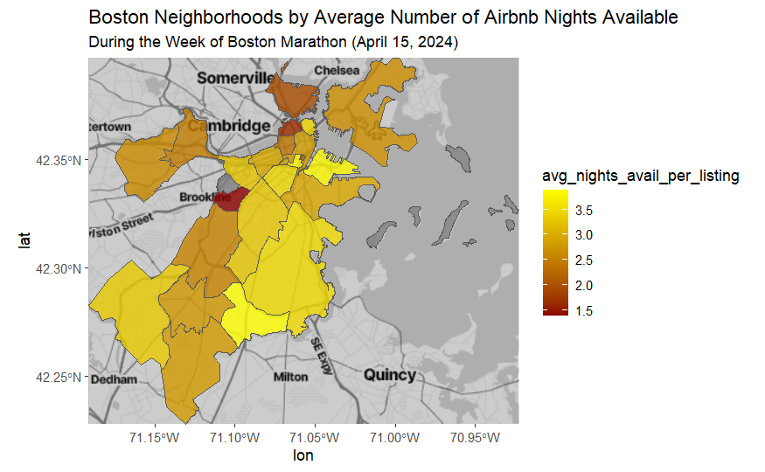mile marker 23-24 of the race (as seen in Figure 14), with close proximity to the Needham line on the commuter rail and the Orange Line for the MTA Subway. The Boston Marathon, though one of the most popular races in the world, is also very selective with their participants. For instance, their total number of competitors in 2024 was around 33,000 – which is about 20,000 less than New York City. Because of this, we would need more data points to determine how many people are travelling to and from and where some of these members are calling home for their stay.

New York City Marathon Week

The New York City map shows that some of the most highly booked were located in Manhattan and mostly the Lower East Side. Though the data we pulled did not have great data for New York City (as evidenced by many of the neighborhoods being marked gray), the availability of listings still is confirmed by what we thought. Though the New 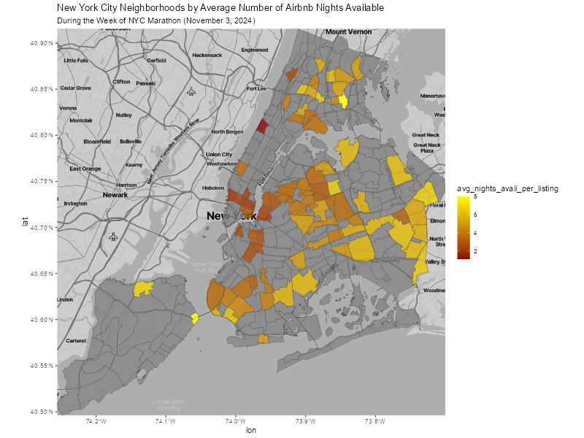York City Marathon is much more compact in terms of area covered, being that the route overlaps in similar streets (see Appendix 2), the neighborhoods in and around Manhattan are surely the most coveted. Finishing in Central Park, the NYC Marathon creates a huge buzz all around the city.

A Morning Brew Daily interview with Mark Levine, Borough President for Manhattan notes that apart from the 50,000 participants, the marathon attracts over 2 million spectators as well. The same interview goes on to mention that the city will recoup around $500 million in marathon related revenue from visitors. While the short term rental market is a small slice of that pie, it is notable that so much of downtown Manhattan is seeing fewer available rooms in the week surrounding the marathon.

San Francisco Marathon Week

The San Francisco data that we were able to pull from shows an interesting distribution of available nights throughout the city during the week of the marathon. If we consider the route of the marathon (see Figure 12), the outskirts of the city should be the most popular and desirable locations for those participating or visiting for the event.

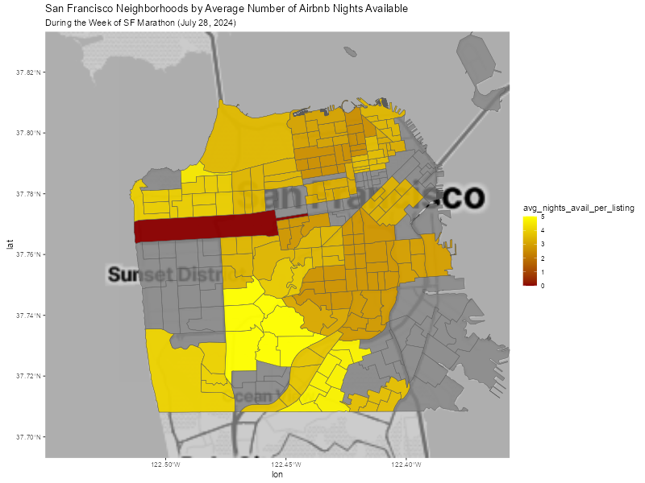

We did see that some of the darker shades of the city are more inland, which could make us believe that these are where the more cost-friendly Airbnb locations are for the week of the event. The west side of the city, the Sunset District, as well as the southeast corner of the city did not have great data for us unfortunately. The long rectangular area that is the darkest shade of red is Golden Gate Park, where not many listings are to begin with, but is clearly the most desired location for visitors.

Denver Marathon Week

The Denver marathon is a bit more unique compared to the other four that we have looked into for this study. On one hand, it is less popular, with fewer participants and visitors visiting The Mile High City in late May for this event. Secondly, the layout of Denver as a city follows much more closely with the likes of Salt Lake City, Phoenix, or other cities established in the 19th century with westward expansion. San Francisco, though situated on the West Coast, lacks some of the land available for a sweeping city of this size. Denver also utilizes a very robust grid system for their city planning, as evidenced by the map below. Chicago and New York do as well, but their city size is much more limited and their proximity to water sources restricts just how much they are able to establish a uniform grid. Figure 16 shows the land area of the five cities that we chose for this case study. New York, on paper, has a very high land area due to its five different boroughs but as we discussed a bit earlier, the geographic makeup of their borough boundaries forces us to treat it much differently than Denver.

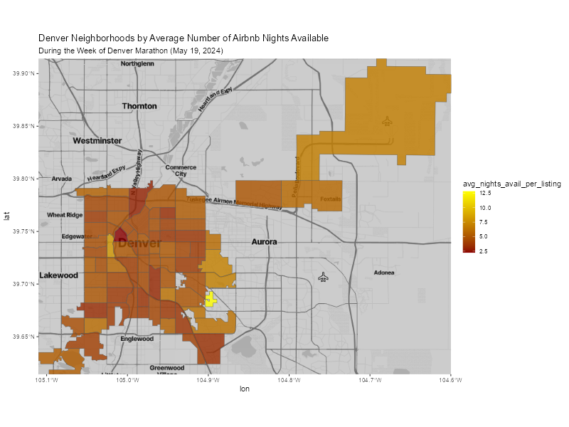

Denver is known for being anything but flat, and that adds some context to both the course layout and the cityscape design in general, but there’s also the added effect that it is a city still growing outwards and a highly popular city to move to (WPA). Denver’s zoning scheme and transit system both focus heavily around I-25, downtown, and the tech center just south of the metro, but that’s also been paired with continued expansion out east towards DIA (Mason). So while much of the existing infrastructure needed to develop Airbnb markets lies along the I-25 corridor, there’s also quite a dispersal out from the hub itself.

Chicago Marathon Week

Chicago’s marathon yielded some of our most interesting results. For one, the representation of every neighborhood appearing was encouraging, as well as some of the darker shades towards Lake Michigan. Figure 11 shows Chicago’s Marathon route, which is one of the most unique in the country. Many say that the route is among the flattest, which makes sense in seeing its route bending and winding through numerous Chicago neighborhoods. Apart from the flatness aiding in speed and lowering competition times, the route in theory makes a lot of the neighborhoods favorable locations to post up for the weekend. Unlike other marathons, specifically Boston, the concentration of the route lends itself well to a better overall distribution of rental locations, instead of individuals opting for spots closer to a downtown area. 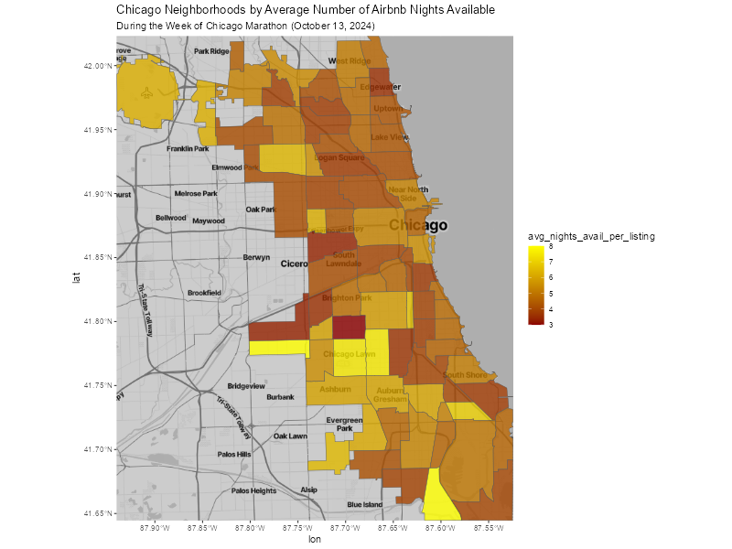

All that said, it is important to note our scale for the average availability of these listings. The darkest red shows around 3 nights of availability which is much more similar to the minimum that we see in Denver compared to the likes of New York and Boston.

Conclusion

This study set out to explore the impact of major marathon events on short-term rental markets in five major U.S. cities: Boston, Chicago, Denver, New York, and San Francisco. By analyzing Airbnb availability, pricing structures, and geographical patterns surrounding these races, we were able to identify trends that visualize how marathon weekends influence local housing markets.

Our findings revealed that in most cities, there was a noticeable decrease in available Airbnb listings during marathon weekends, suggesting a surge in demand from runners, spectators, and other visitors which reinforce the idea that marathon weekends are a key driver of short-term rental bookings, particularly in cities with prestigious races. New York City findings however, showed an increase in available listings during its marathon weekend, which could have been due to the vast size of their short-term rental market. Future research could delve deeper into this anomaly to determine whether it is a consistent trend or a result of unique circumstances in 2024.

While some neighborhoods did exhibit increased prices during marathon weekends, pricing did not show a consistent, statistically significant pattern across cities, which suggests that while demand for Airbnbs rises during these events, hosts may not always adjust their pricing accordingly. Our study also highlighted the importance of location in Airbnb rental patterns. Neighborhoods closest to marathon courses, particularly those near race start and finish lines, tended to have the highest levels of booking activity. In cities like Boston and Chicago, for example, areas near the race route had lower Airbnb availability, suggesting that these neighborhoods are particularly desirable for marathon participants and spectators.

One potential avenue of future research is to incorporate hotel occupancy data to compare how short-term rentals and traditional accommodations interact during marathon weekends. Additionally, studying the impact of city regulations on short-term rental availability could provide insight into how policy decisions influence market behavior. Further research could also examine the long-term effects of annual large-scale events on local rental markets—do cities with major marathons experience sustained changes in their short-term rental landscape over time, or are the effects limited to race weekends?

Ultimately, our findings reinforce the idea that events like marathons have a tangible effect on local markets especially within short-term real estate. Understanding these dynamics can help city planners, policymakers, and Airbnb hosts better anticipate market shifts and optimize strategies for accommodating visitors. With marathon participation continuing to grow, the intersection of tourism and short-term rentals will remain an important area for future analysis.

Sources

"How Much Will the Results of the 2024 Boston Marathon Impact the Cutoff Time for 2025?" runningwithrock.com, 12 Sept. 2024, <https://runningwithrock.com/boston-2025-cutoff-impact/>

Lewellyn, Amanda. "Why everyone you know is running a marathon." *Vox*, Vox Media, 15 Nov. 2024, <https://www.vox.com/even-better/385283/train-marathon-gen-z>. Accessed 24 Feb. 2025.

Mason, Tori. "Aurora Development Plan Aims to Transform East Colfax Avenue." *CBS News Colorado*, 29 Feb. 2024,<https://www.cbsnews.com/colorado/news/aurora-development-plan-east-colfax-avenue/>.

Morning Brew. "I Ran the NYC Marathon to Find Out How Marathons Make Money." YouTube, uploaded by Morning Brew, 4 Nov. 2024, <http://www.youtube.com/watch?v=uMJpSB0Q46E>.

World Population Review."Denver, Colorado Population 2024." *World Population Review*, 2024,<https://worldpopulationreview.com/us-cities/colorado/denver>.

Appendix

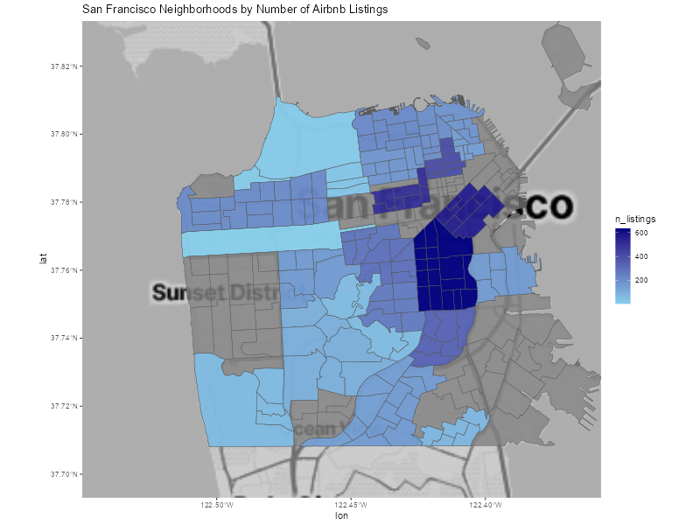

Figure 1. Representing the density of listings in San Francisco

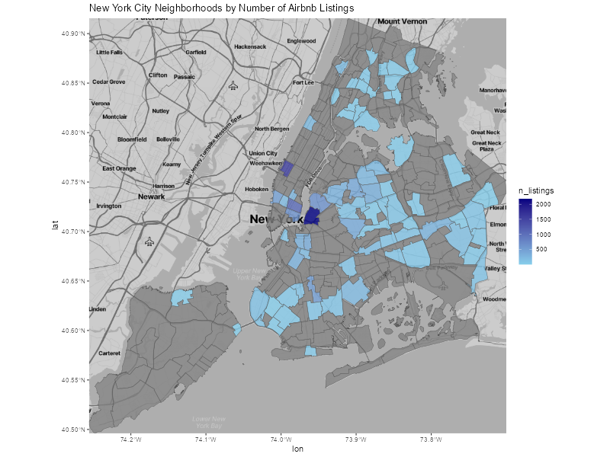

Figure 2. Representing the density of listings in New York

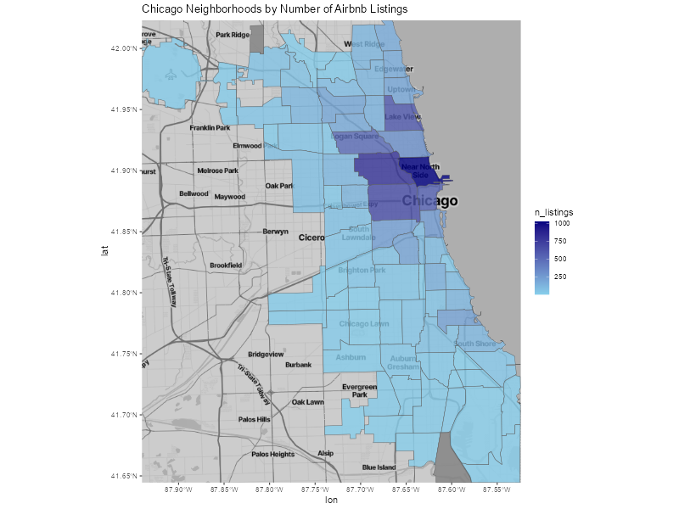

Figure 3. Representing the density of listings in Chicago

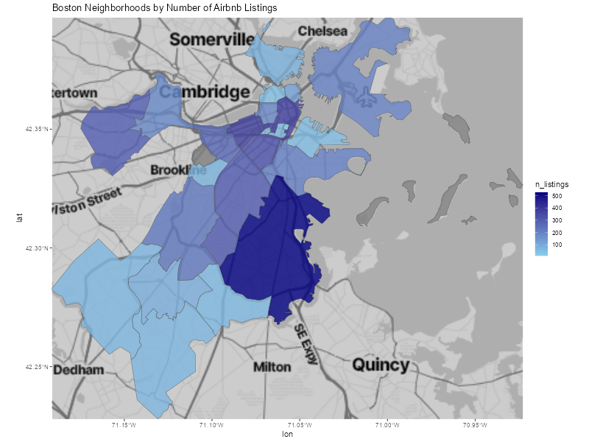

Figure 4. Representing the density of listings in Boston

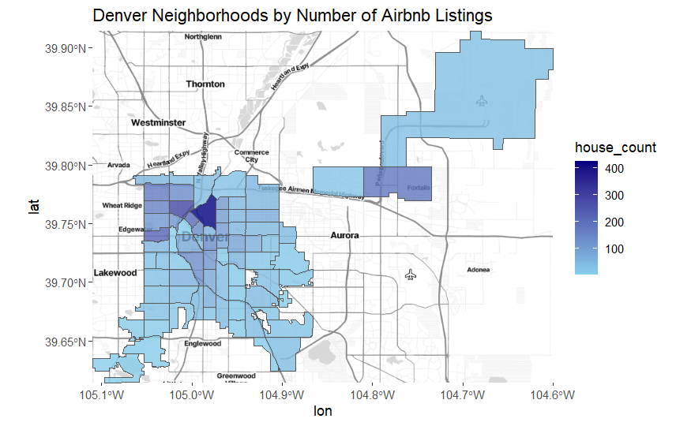

Figure 5. Representing the density of listings in Denver

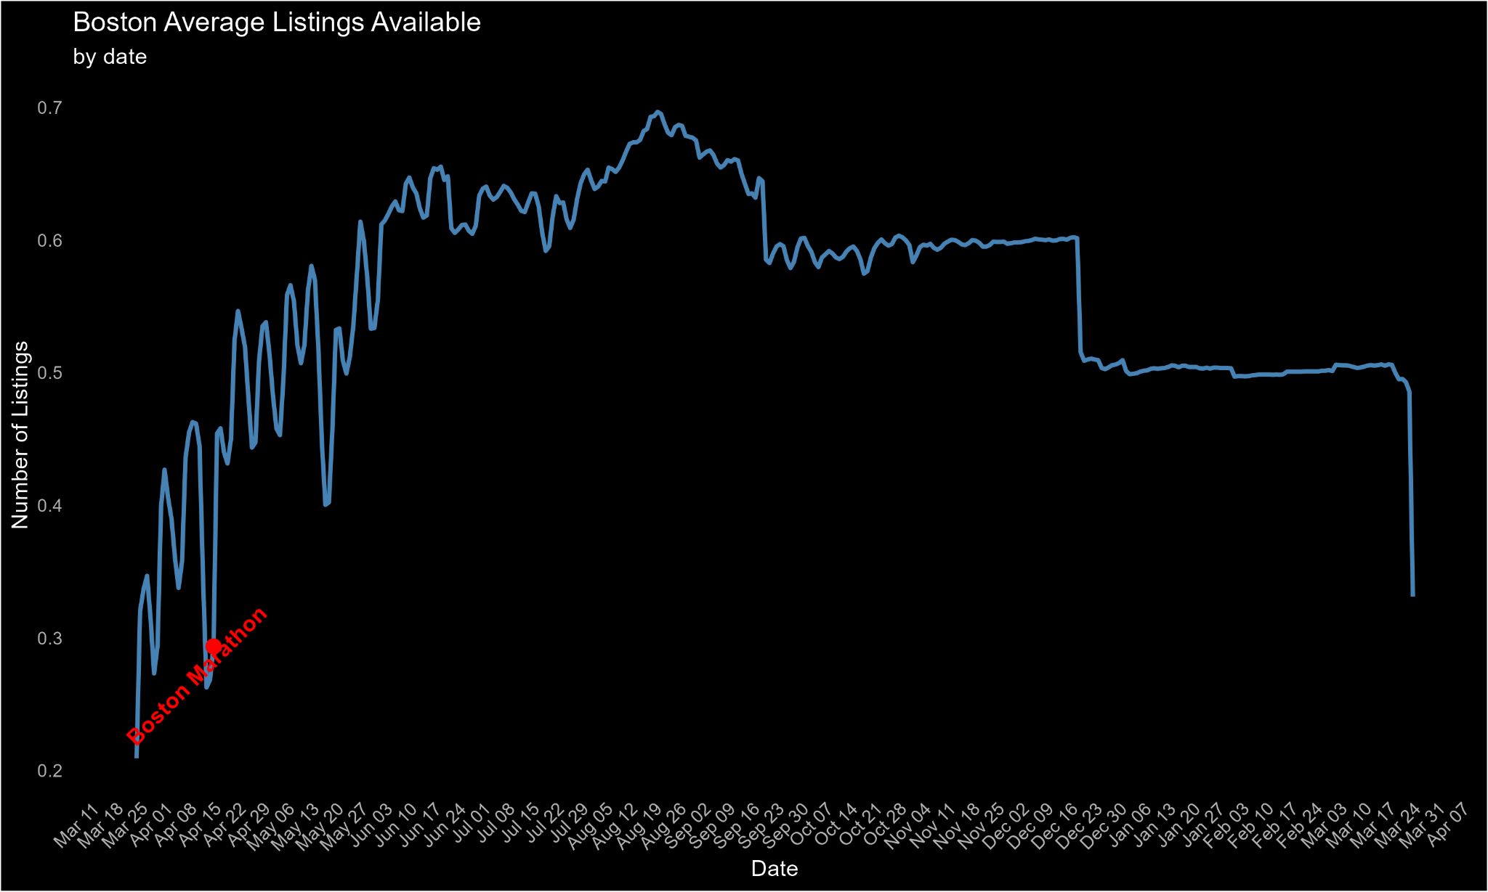

Figure 6. Representing the time-series of listings within Boston

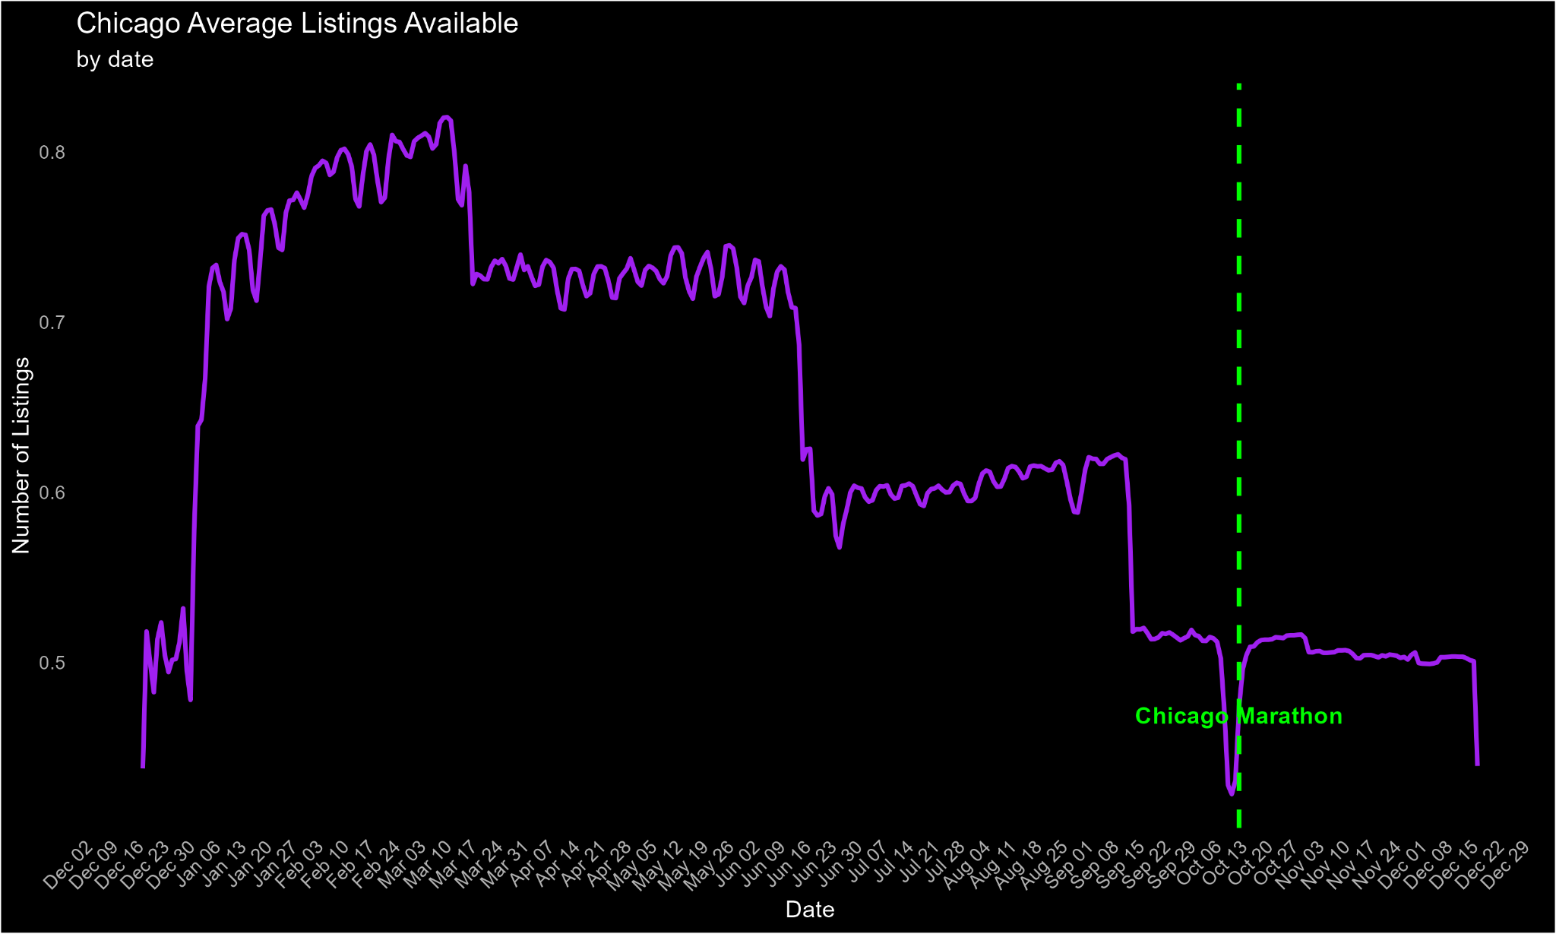

Figure 7. Representing the time-series of listings within Chicago

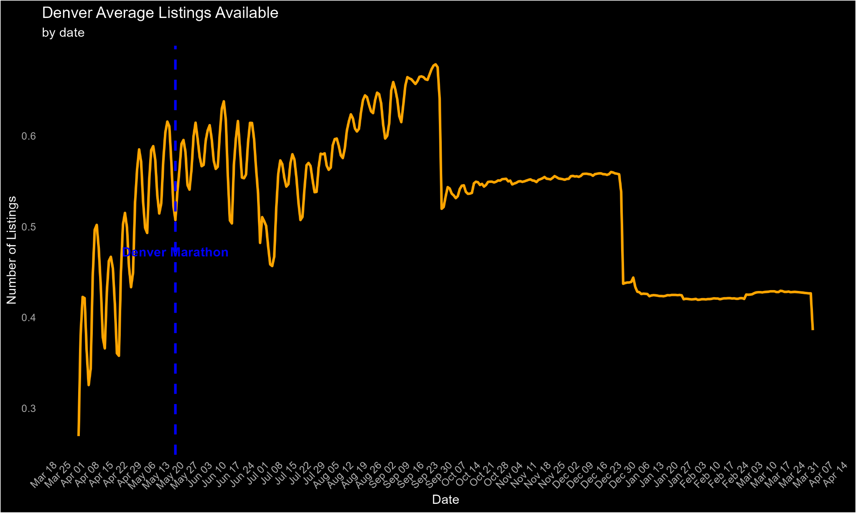

Figure 8. Representing the time-series of listings within Denver

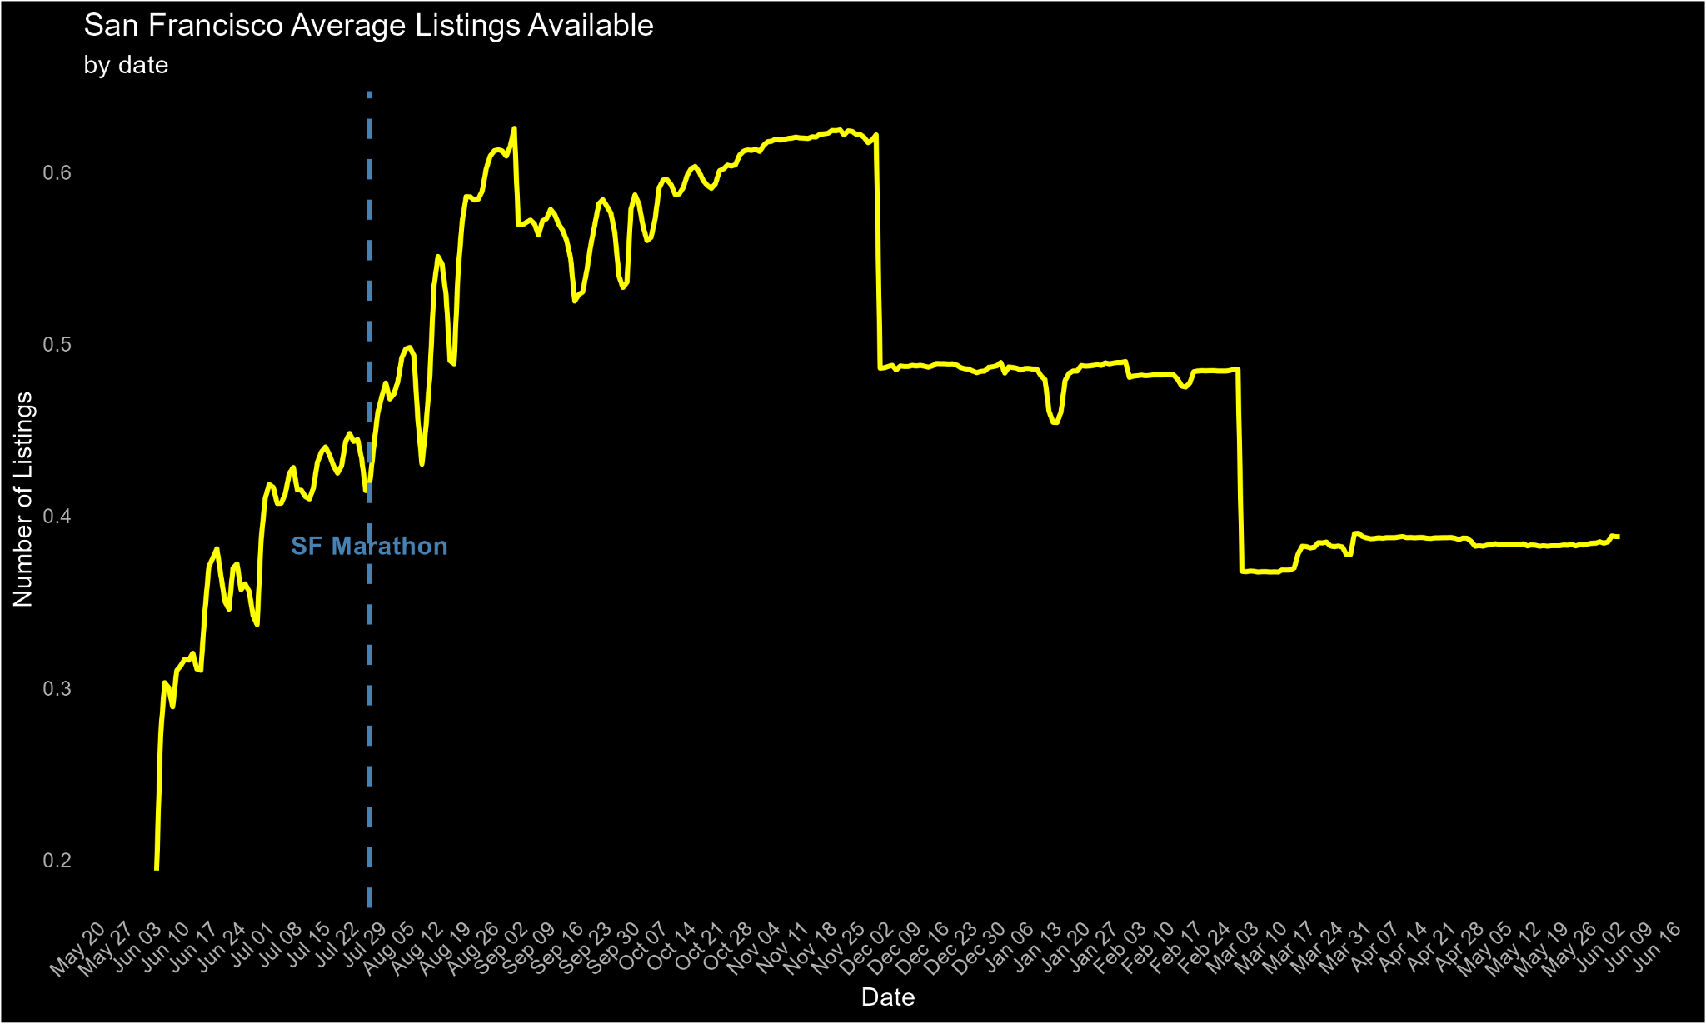

Figure 9. Representing the time-series of listings within San Francisco

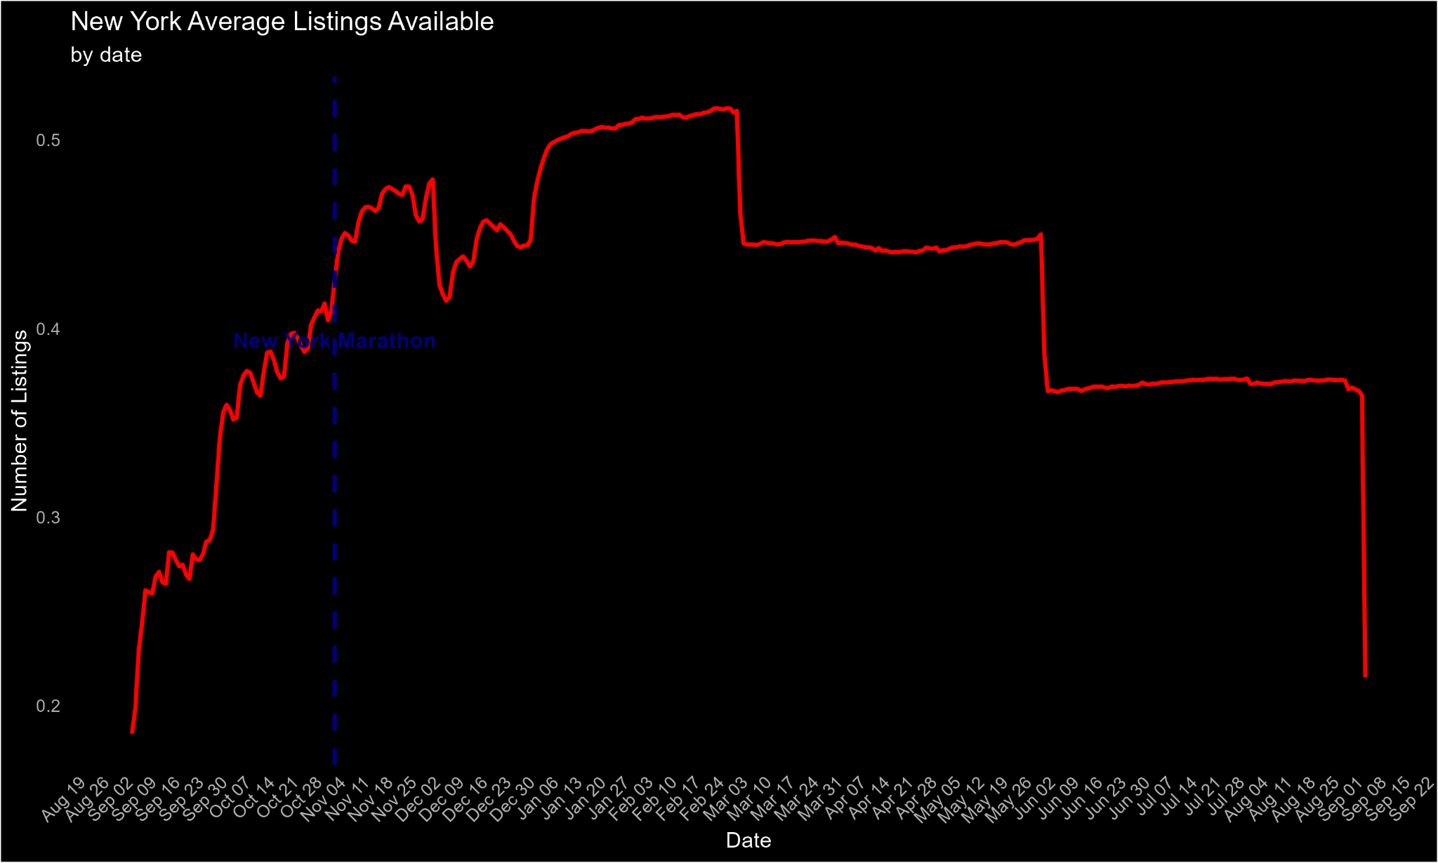

Figure 10. Representing the time-series of listings within New York

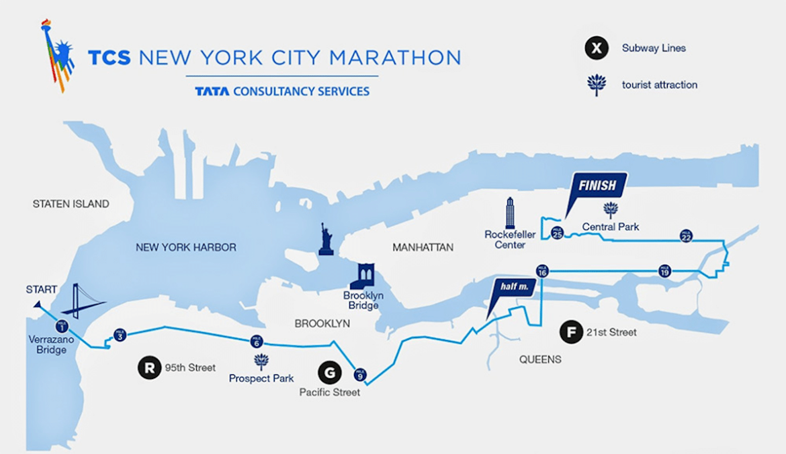

Figure 11. The Map of the New York City Marathon Route gathered from:

<https://www.reggaemarathon.com/wp-content/uploads/2019/10/nyc-marathon-landmark-route-map_1190-1170x677.png>

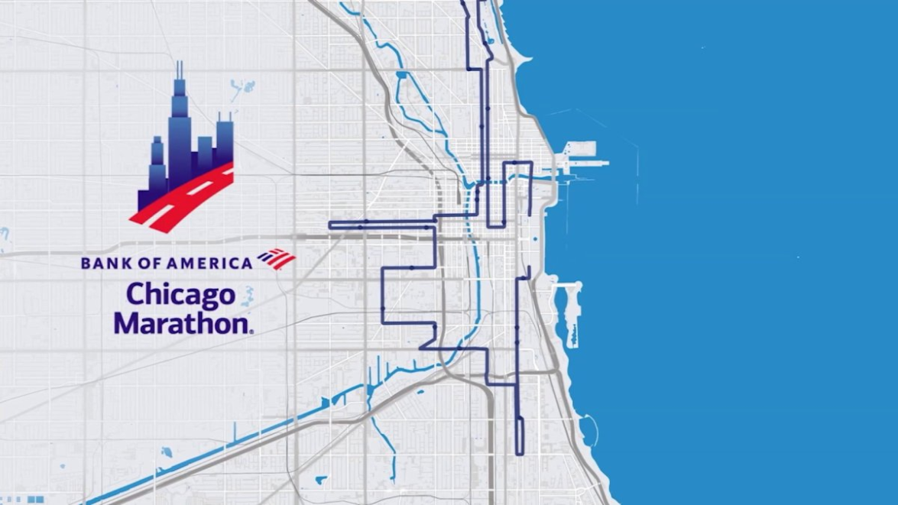

Figure 12. The Map of the Chicago Marathon Route gathered from:

<https://www.nbcchicago.com/news/local/map-see-the-chicago-marathon-course-route-from-start-to-finish/3566990/>

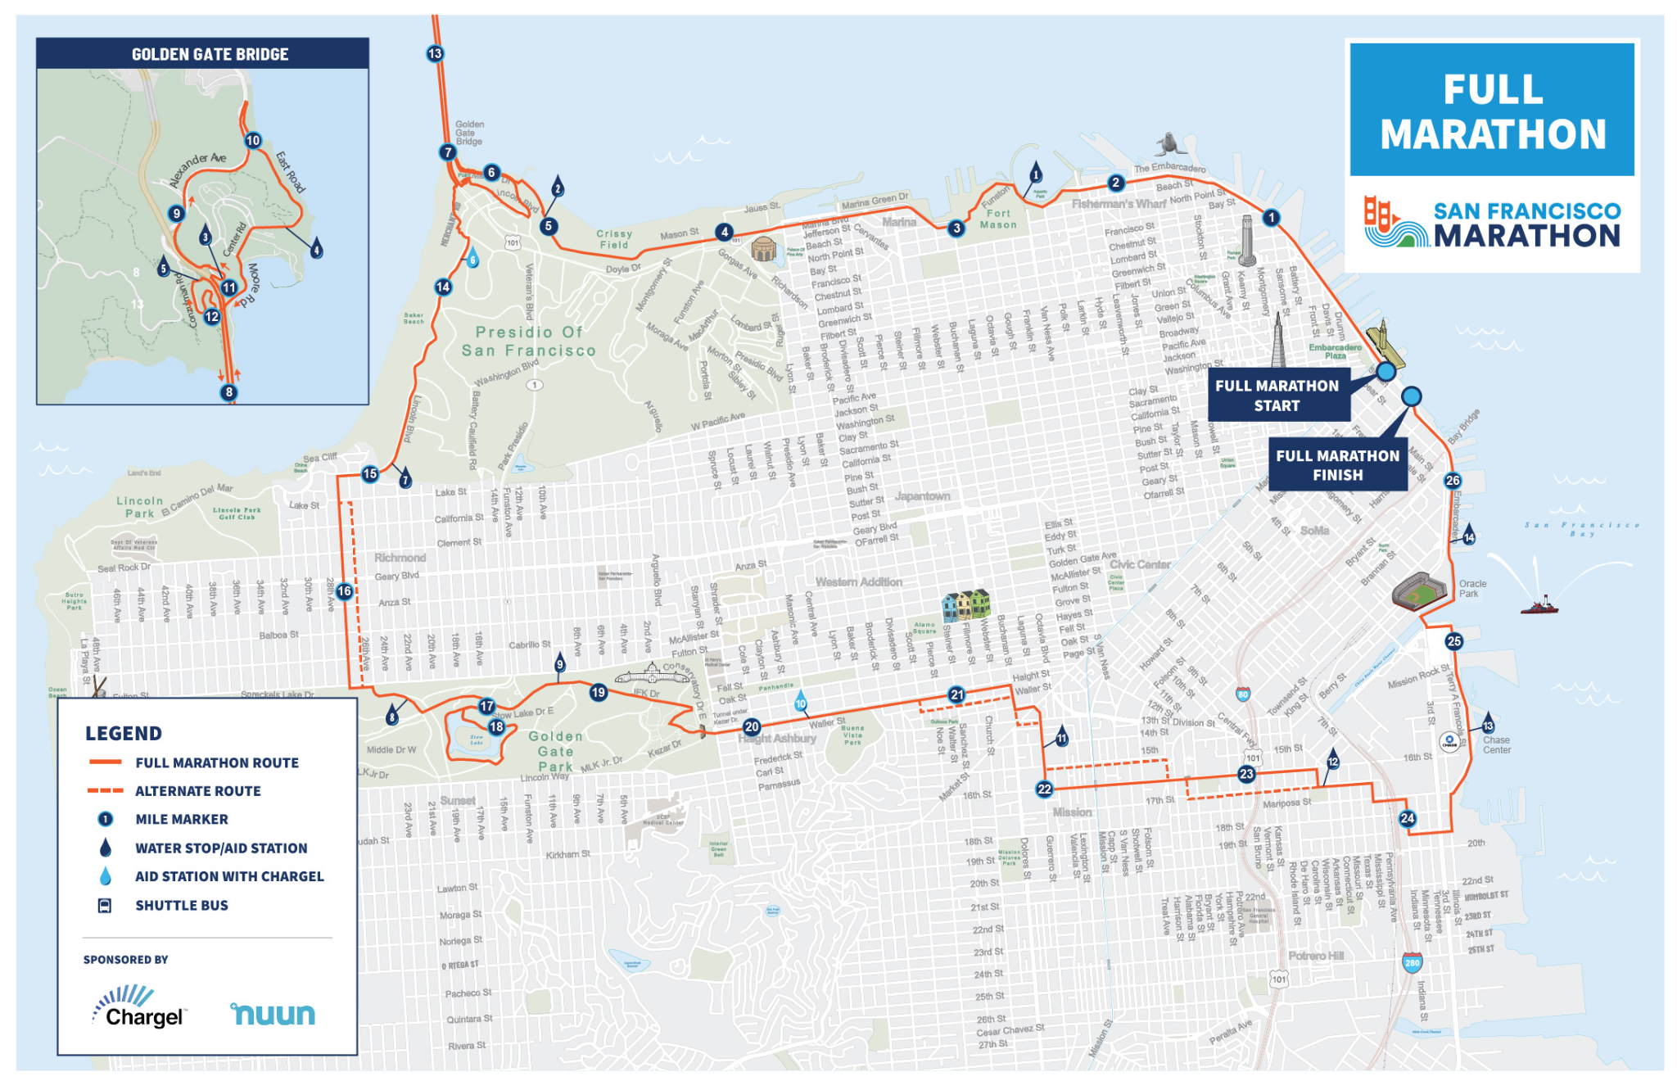

Figure 13. The Map of the San Francisco Marathon Route gathered from:

<https://www.thesfmarathon.com/wp-content/uploads/2024/07/Full_Marathon.pdf>

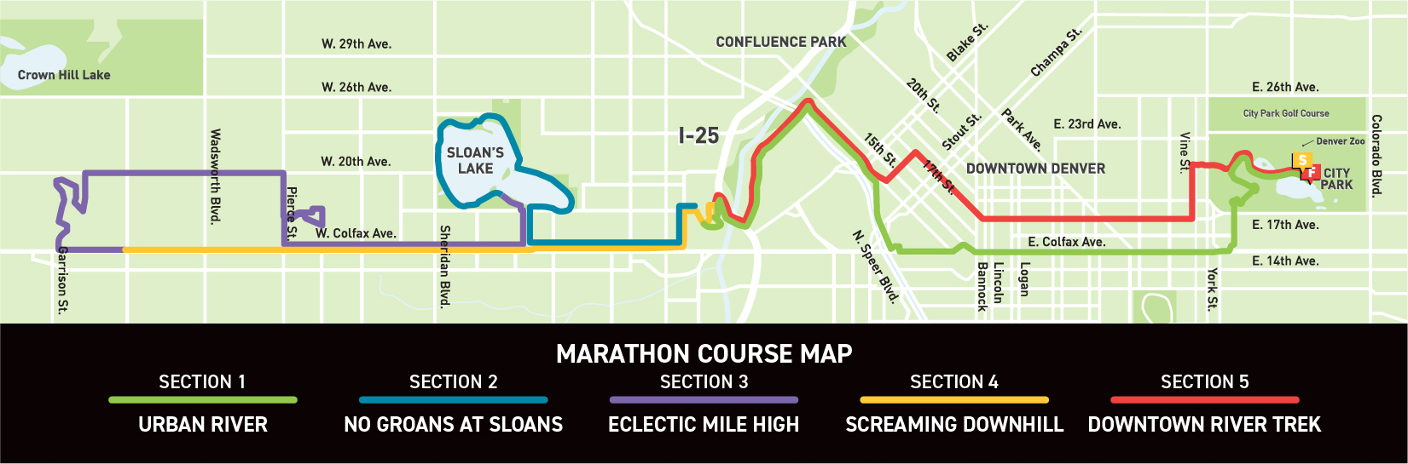

Figure 14. The Map of the Denver Marathon Route gathered from:

<https://www.runcolfax.org/races/marathon-course-overview/>



Figure 15. The Map of the Boston Marathon Route gathered from:

<https://www.baa.org/sites/default/files/inline-images/128thBMCourseMap_0.png>

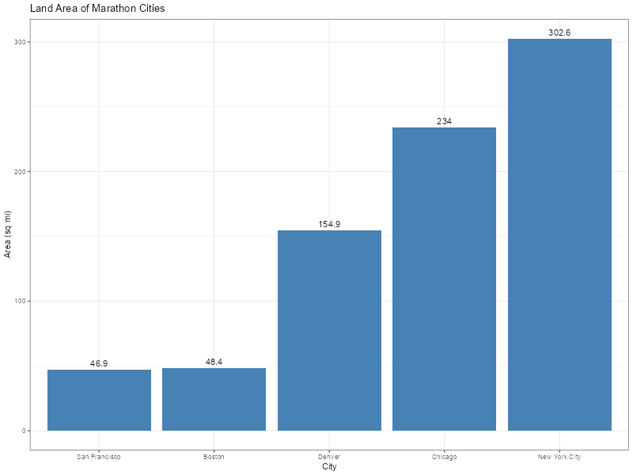

Figure 16. Land Area of Marathon Cities in Sq Miles

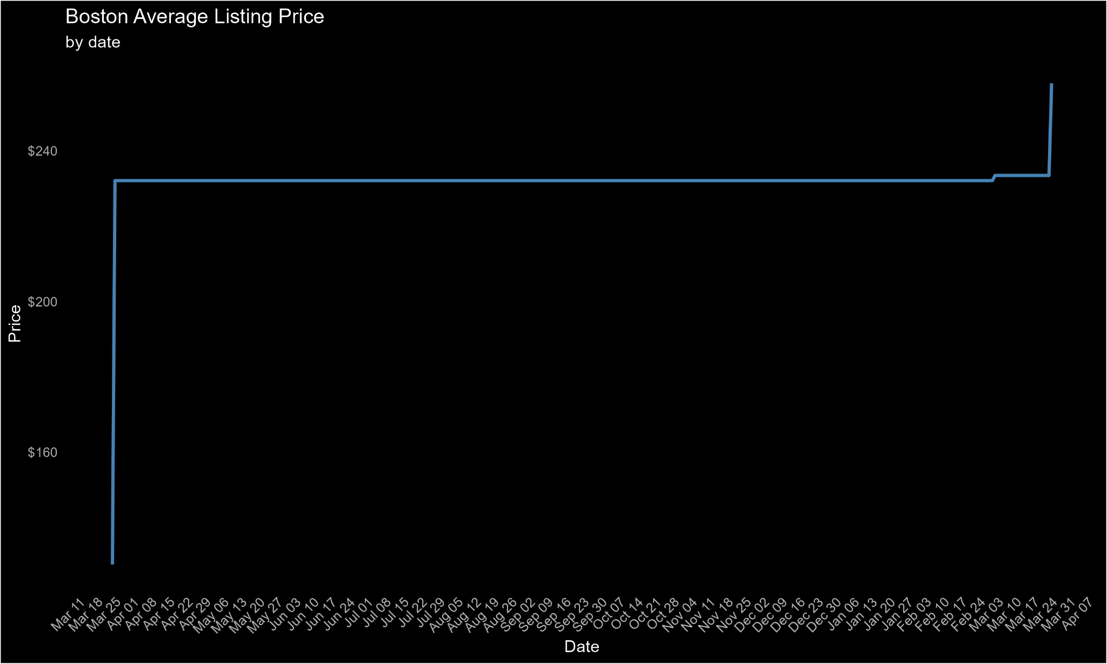

Figure 17. Boston Airbnb pricing over 2024

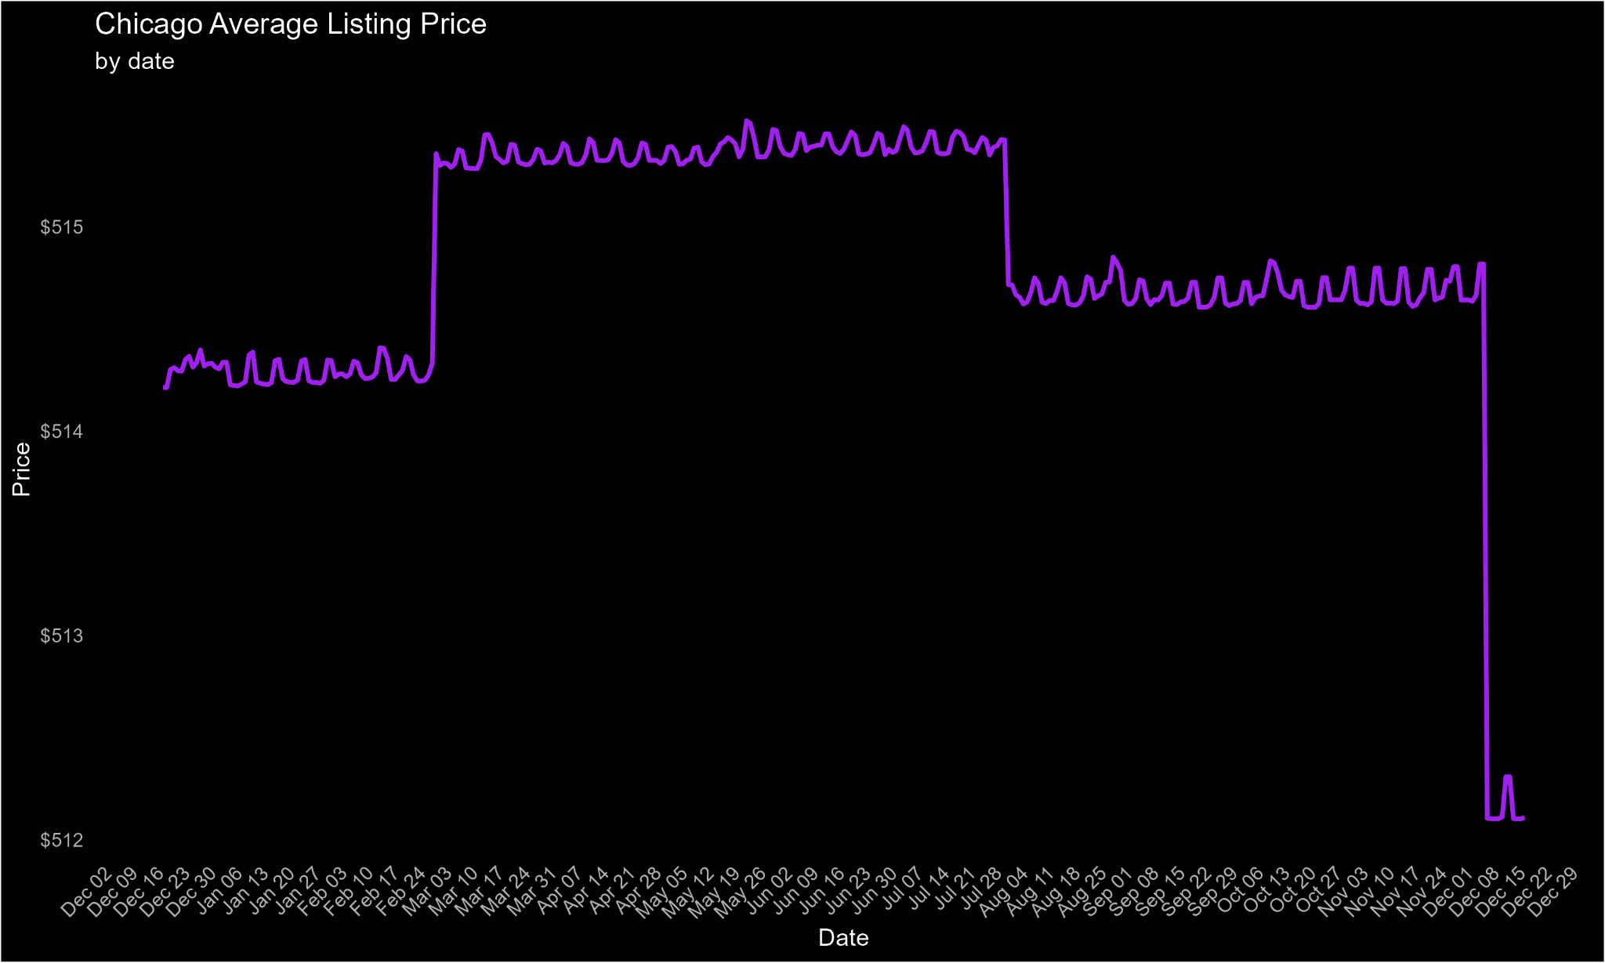

Figure 18. Chicago Airbnb pricing over 2024

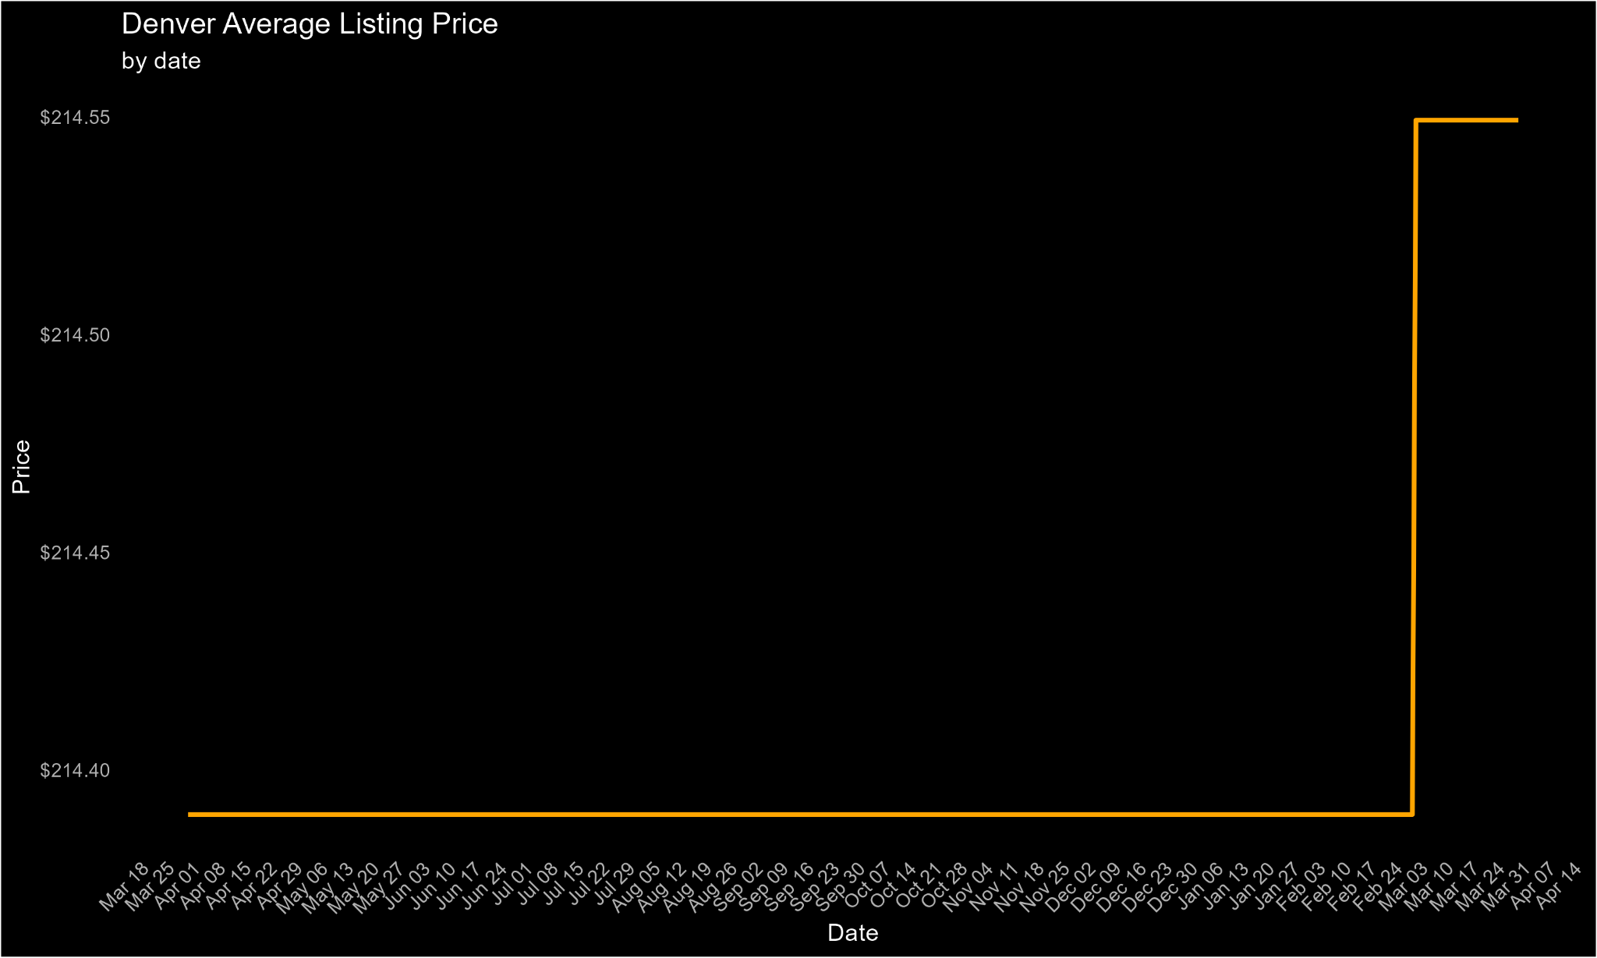

Figure 19. Denver Airbnb pricing over 2024

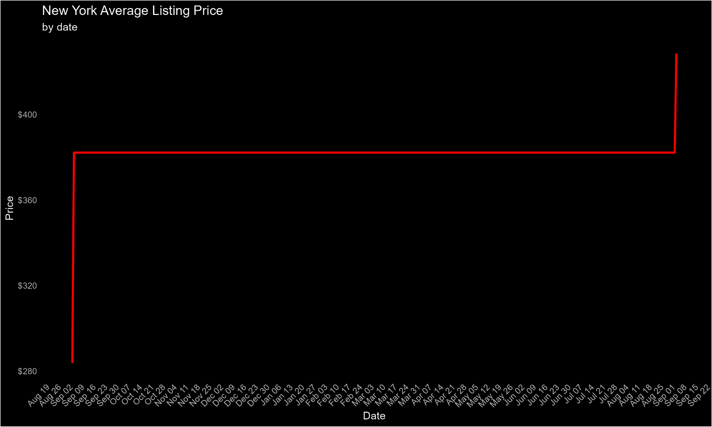

Figure 20. New York Airbnb pricing over 2024

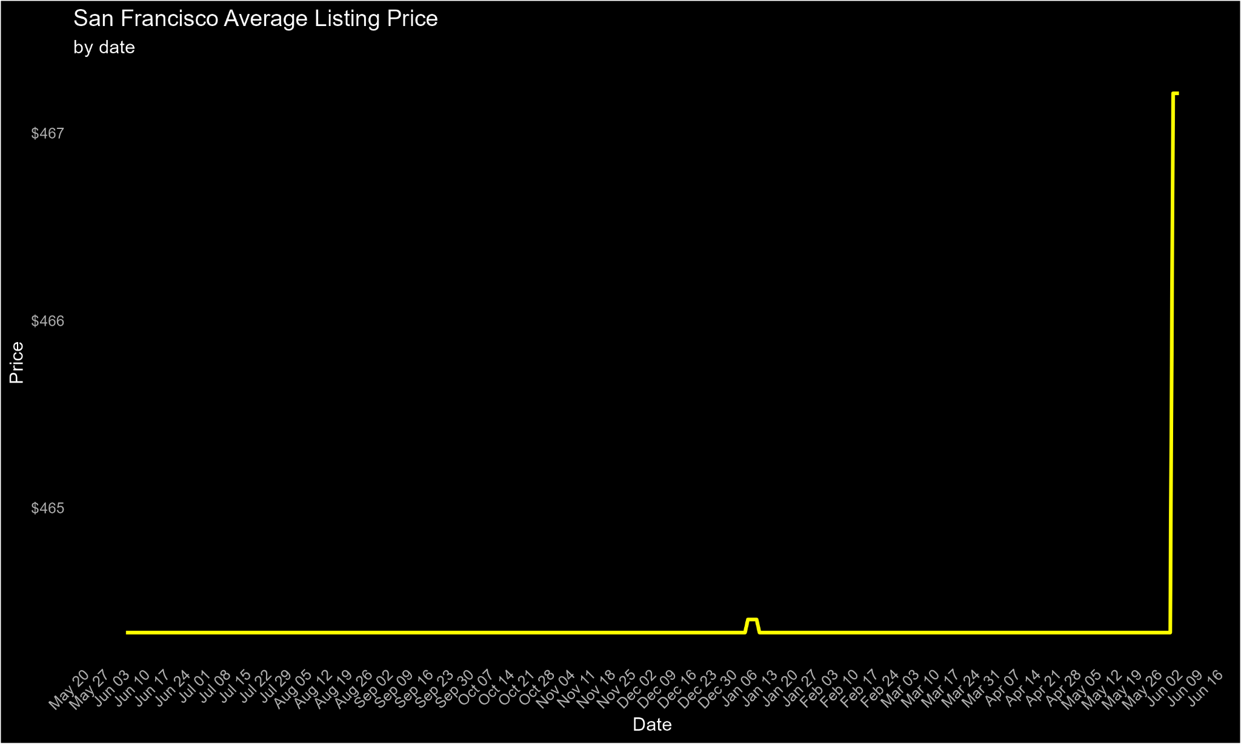

Figure 21. San Francisco Airbnb pricing over 2024

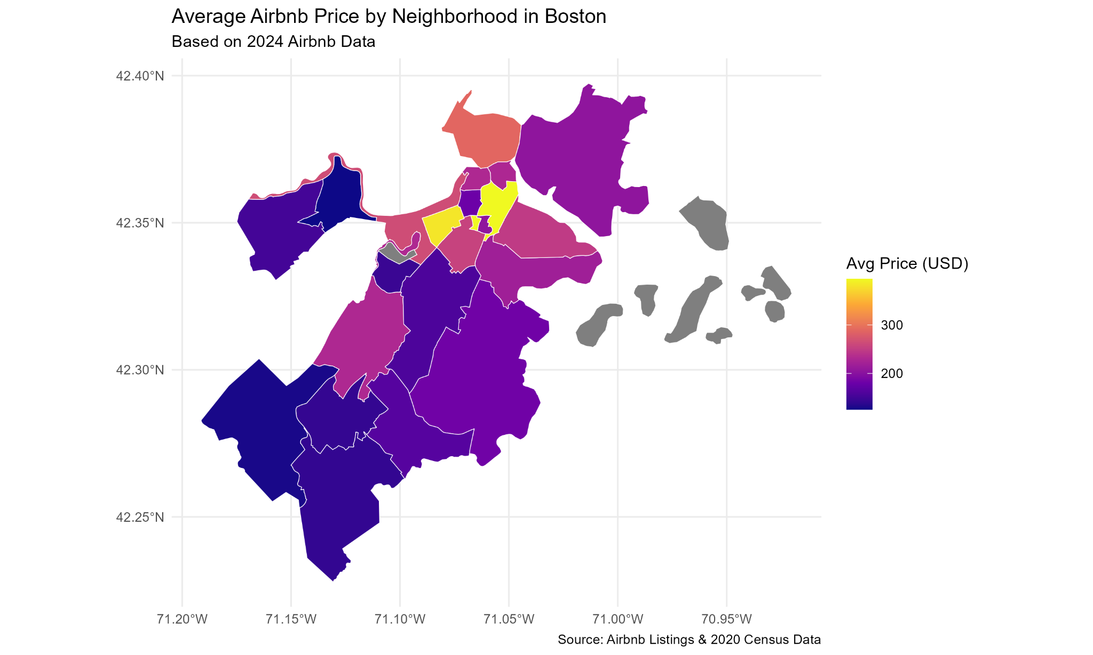

Figure 22. Displaying Airbnb Pricing for San Francisco’s neighborhoods 2024

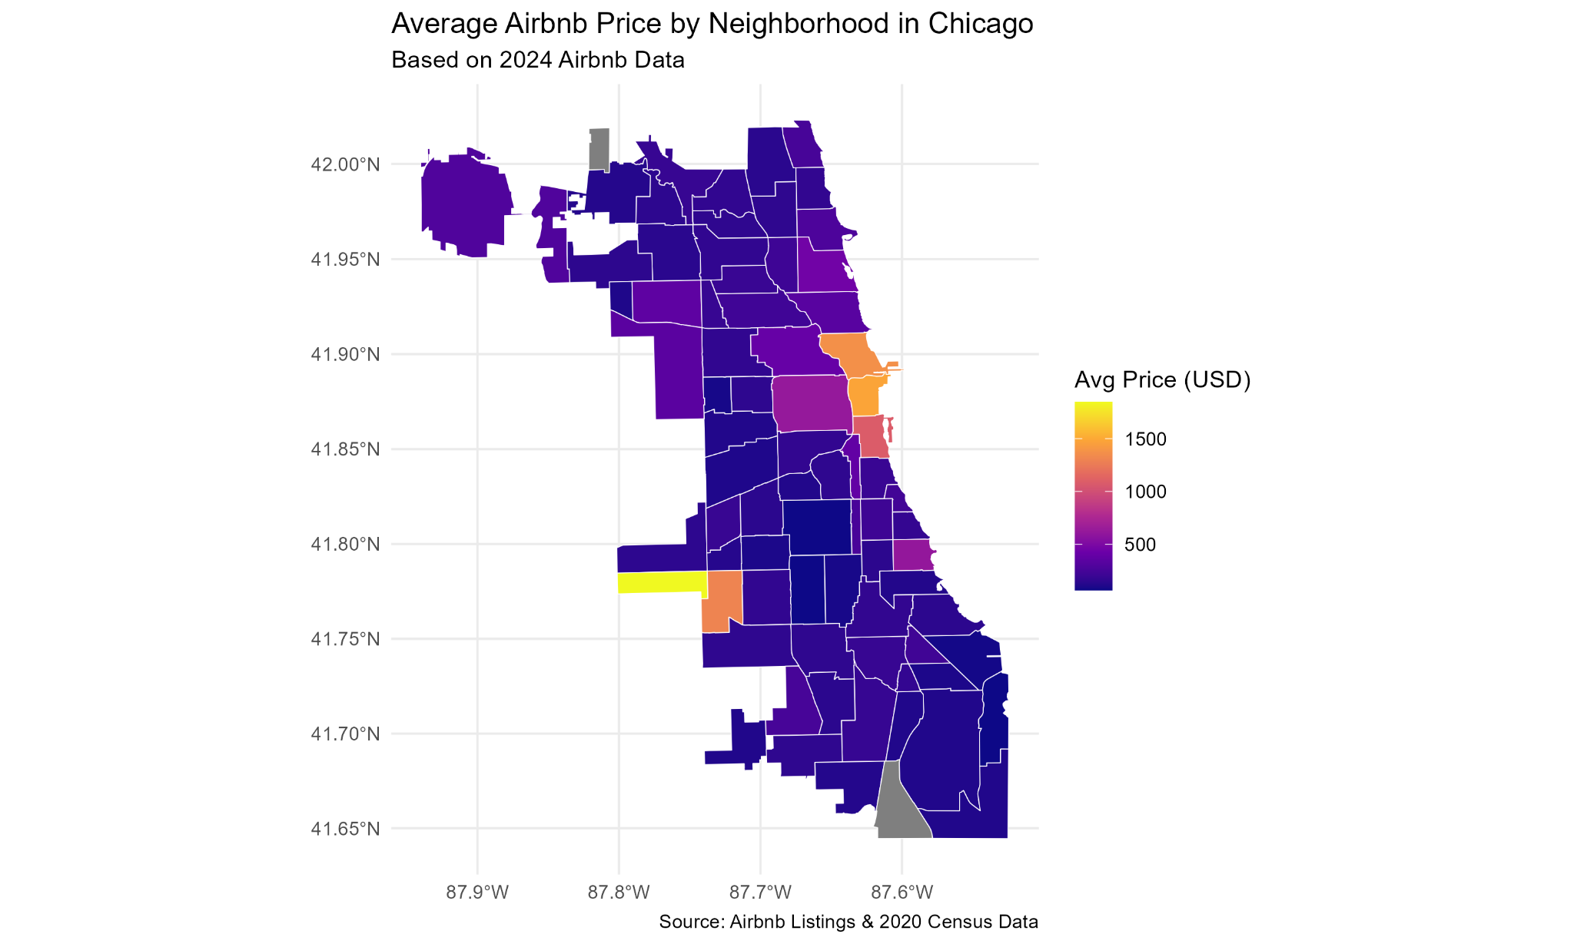

Figure 23. Displaying Airbnb Pricing for Chicago’s neighborhoods 2024

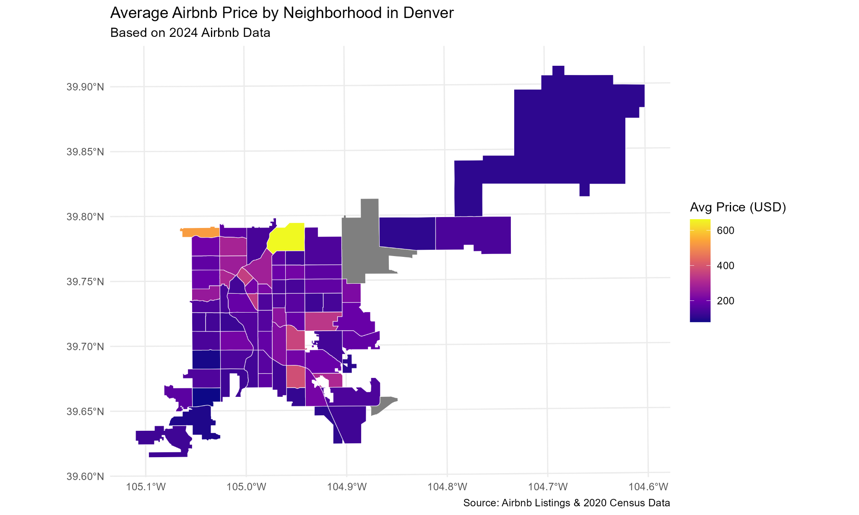

Figure 24. Displaying Airbnb Pricing for Denver’s neighborhoods 2024

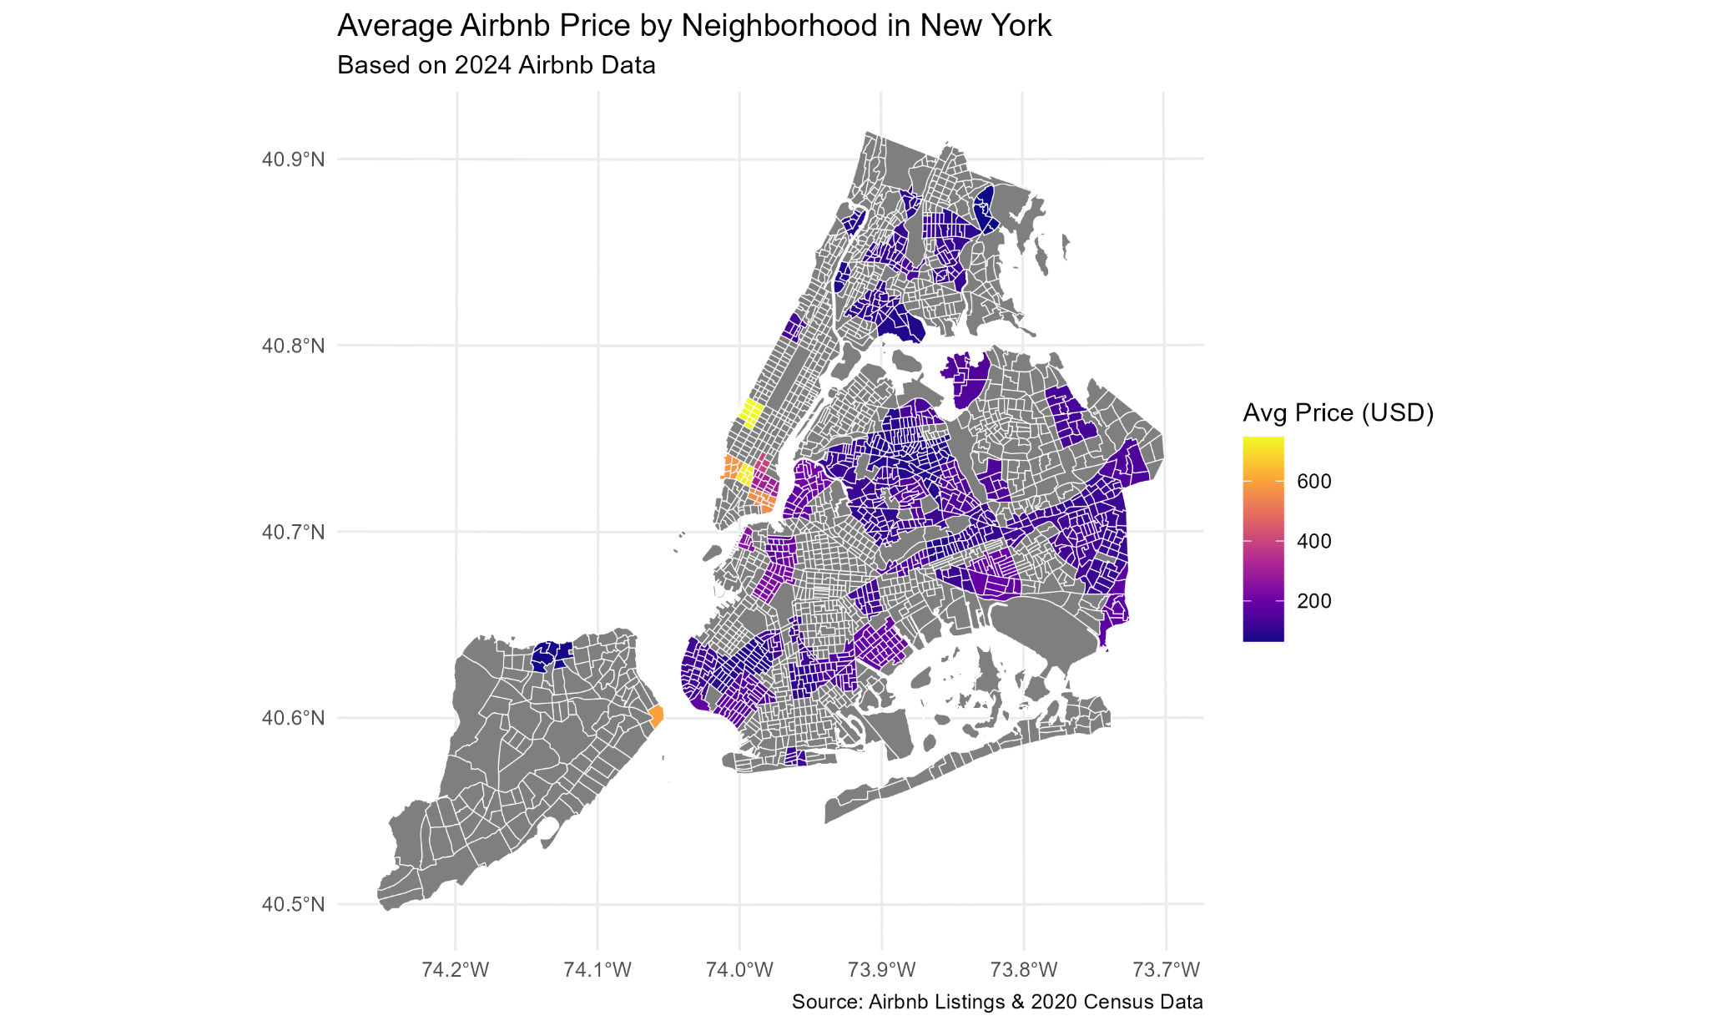

Figure 25. Displaying Airbnb Pricing for New York’s neighborhoods 2024

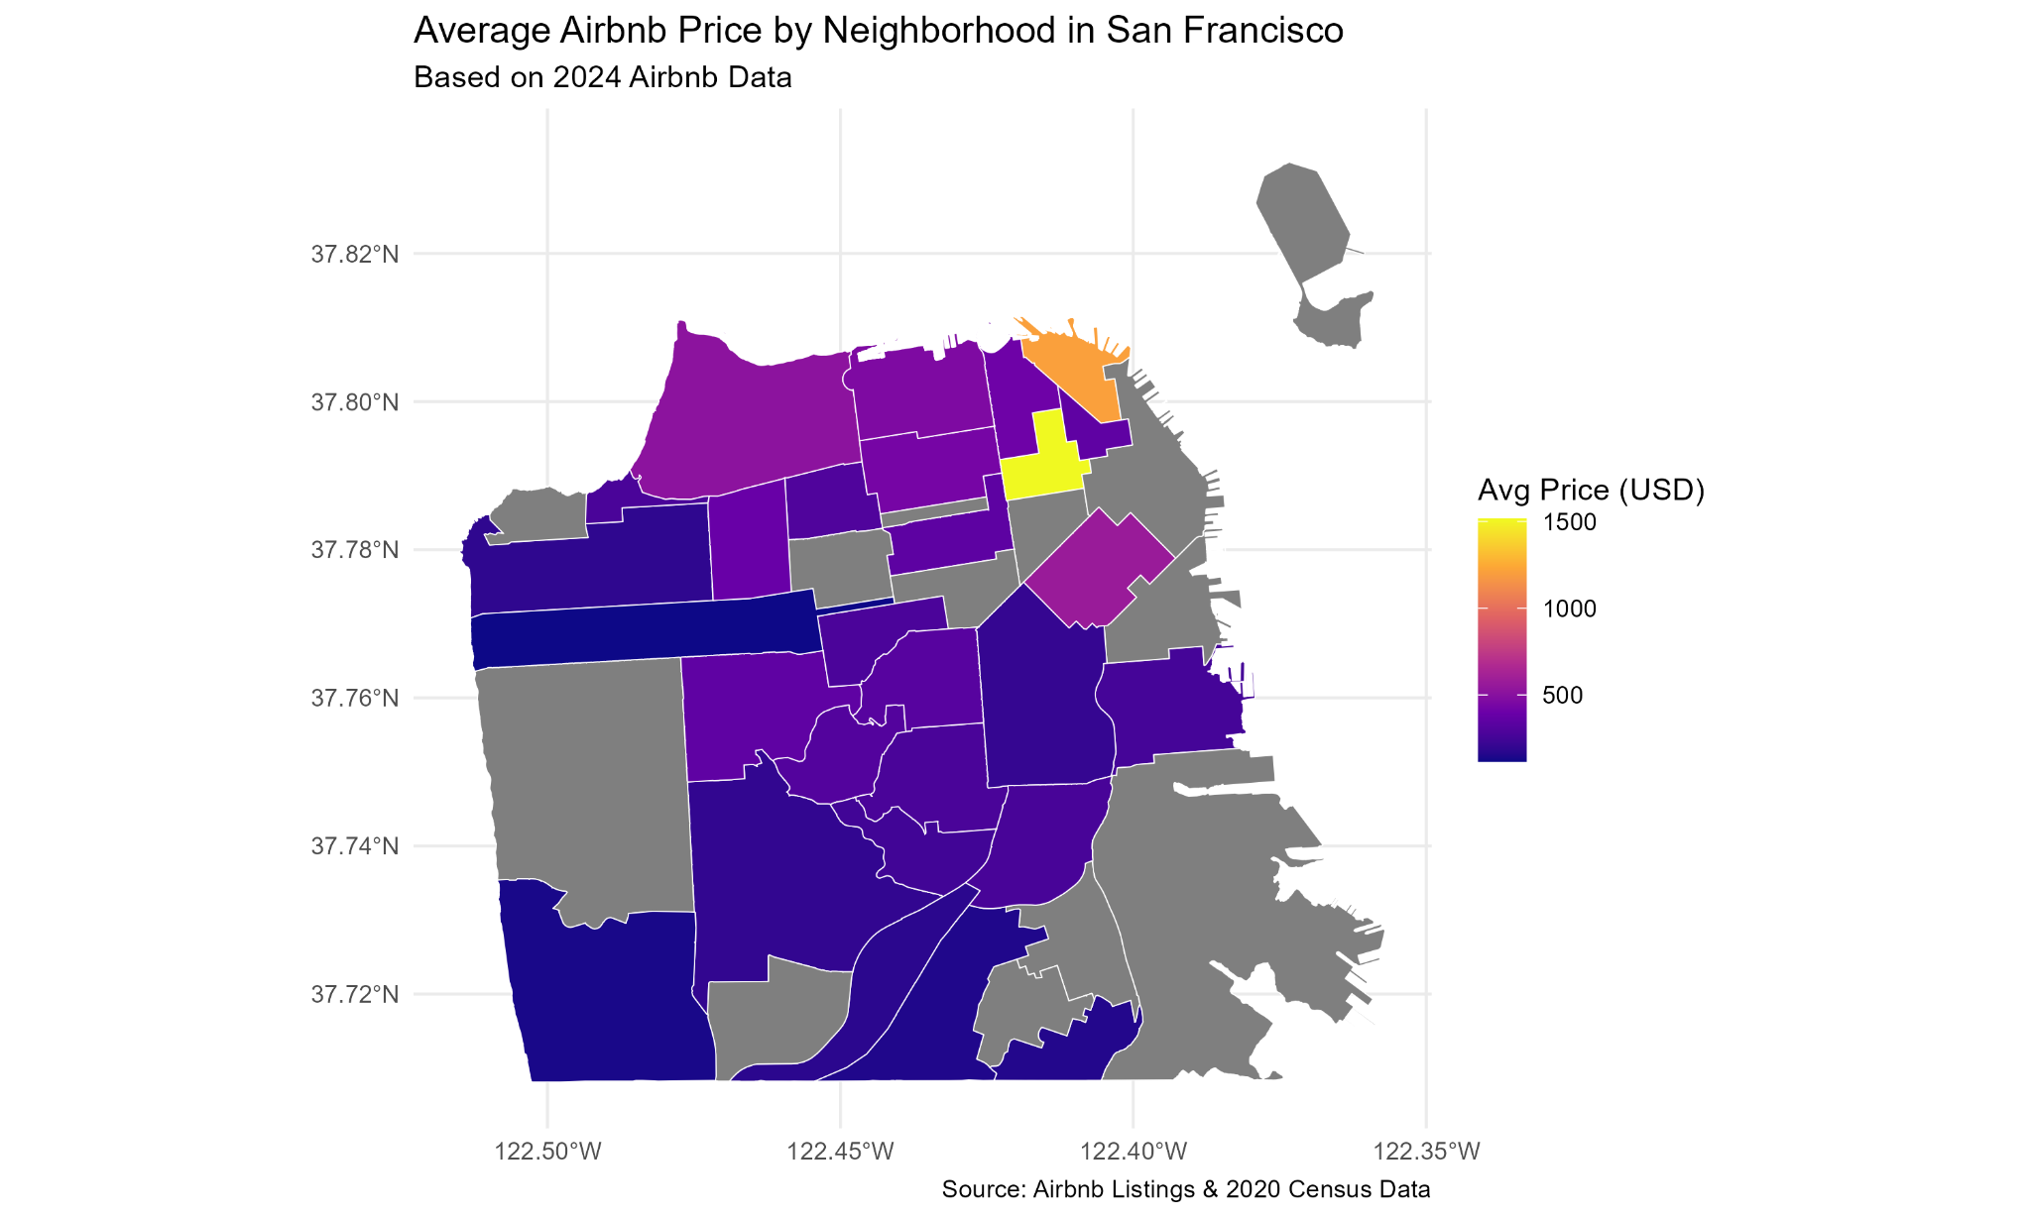

Figure 26. Displaying Airbnb Pricing for San Francisco’s neighborhoods 2024

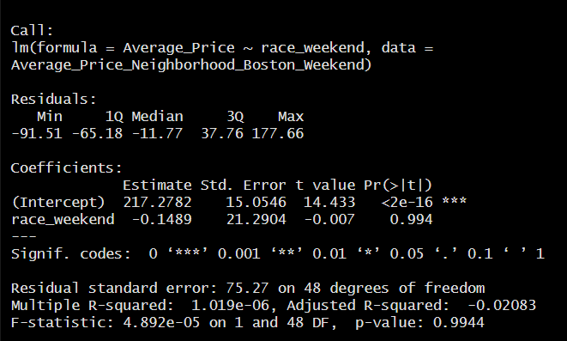

Figure 27. The Diagnostic results from the Boston race weekend Linear Regression model

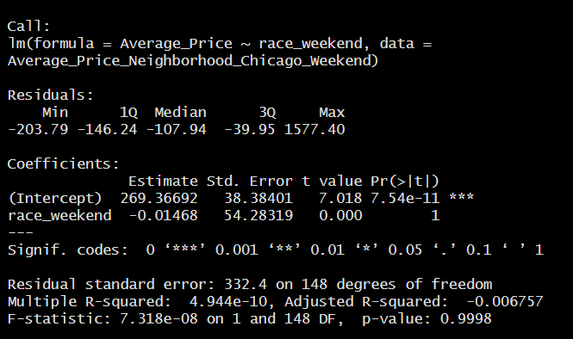

Figure 28. The Diagnostic results from the Chicago race weekend Linear Regression model

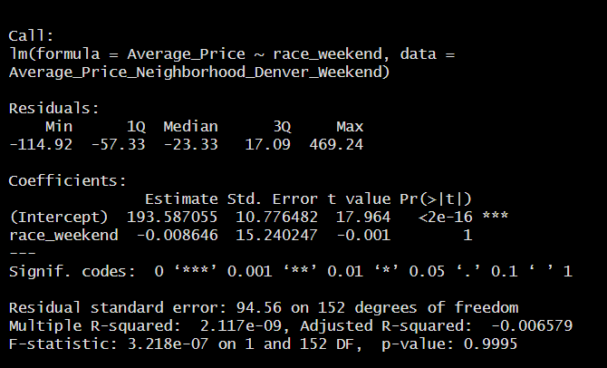

Figure 29. The Diagnostic results from the Denver race weekend Linear Regression model

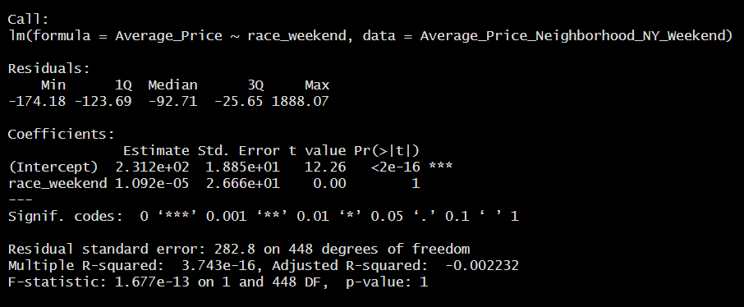

Figure 30. The Diagnostic results from the New York race weekend Linear Regression model

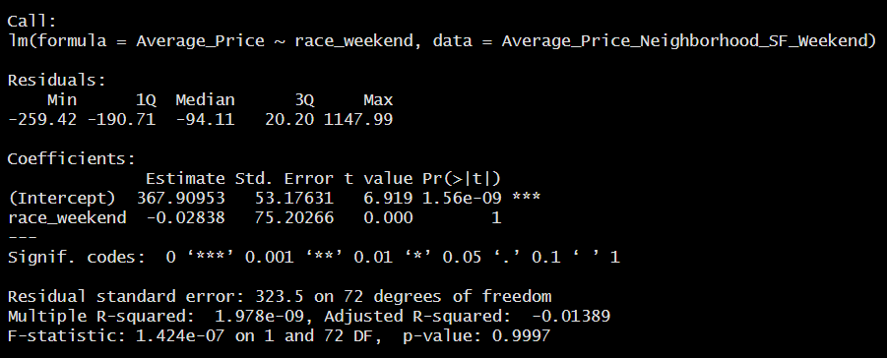

Figure 31. The Diagnostic results from the San Francisco race weekend Linear Regression model

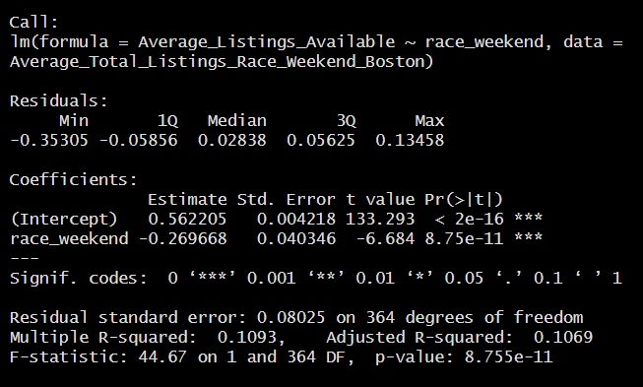

Figure 32. The Diagnostic results from the Boston race weekend Linear Regression model on Availability

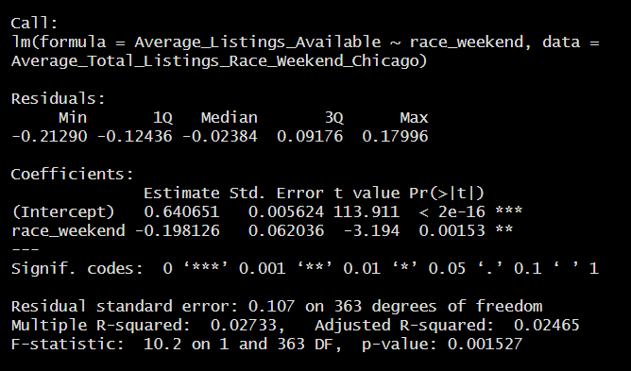

Figure 33. The Diagnostic results from the Chicago race weekend Linear Regression model on Availability

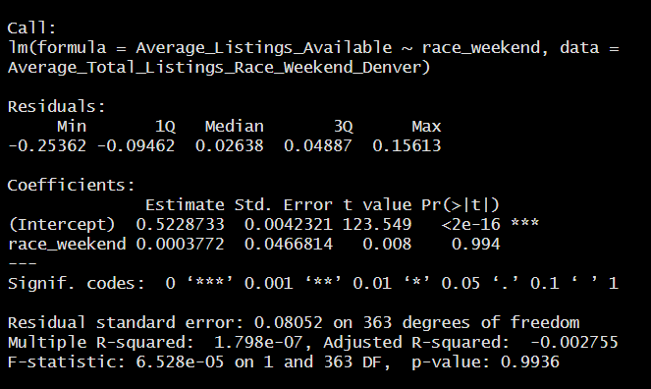

Figure 34. The Diagnostic results from the Denver race weekend Linear Regression model on Availability

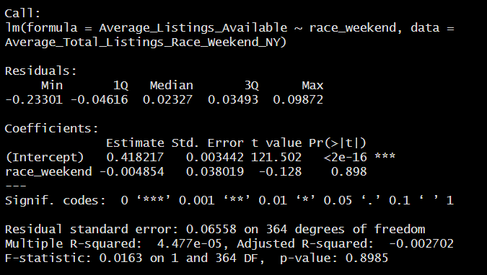

Figure 35. The Diagnostic results from the New York race weekend Linear Regression model on Availability

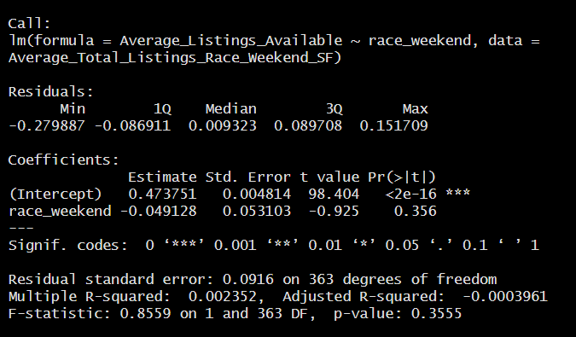

Figure 36. The Diagnostic results from the San Francisco race weekend Linear Regression model on Availability